LEGAL HELP

A Project Report

##### Submitted in partial fulfilment of

##### the Requirements for the award of the Degree of

**BACHELOR OF SCIENCE (INFORMATION TECHNOLOGY)**

By

**Ahmad Raza Ansari (59)**

Seat Number:

**Naseem Shaikh (48)**

Seat Number:

**Under the esteemed guidance of**

**Prof. Ahtesham Shaikh**

**Prof. Shahid Parvez**

**Department of Information Technology**



DEPARTMENT OF INFORMATION TECHNOLOGY

**AKBAR PEERHOY COLLEGE OF COMMERCE AND ECONOMICS**

*(Affiliated to University of Mumbai)*

MUMBAI, 400 008 MAHARASHTRA

2025 - 2026

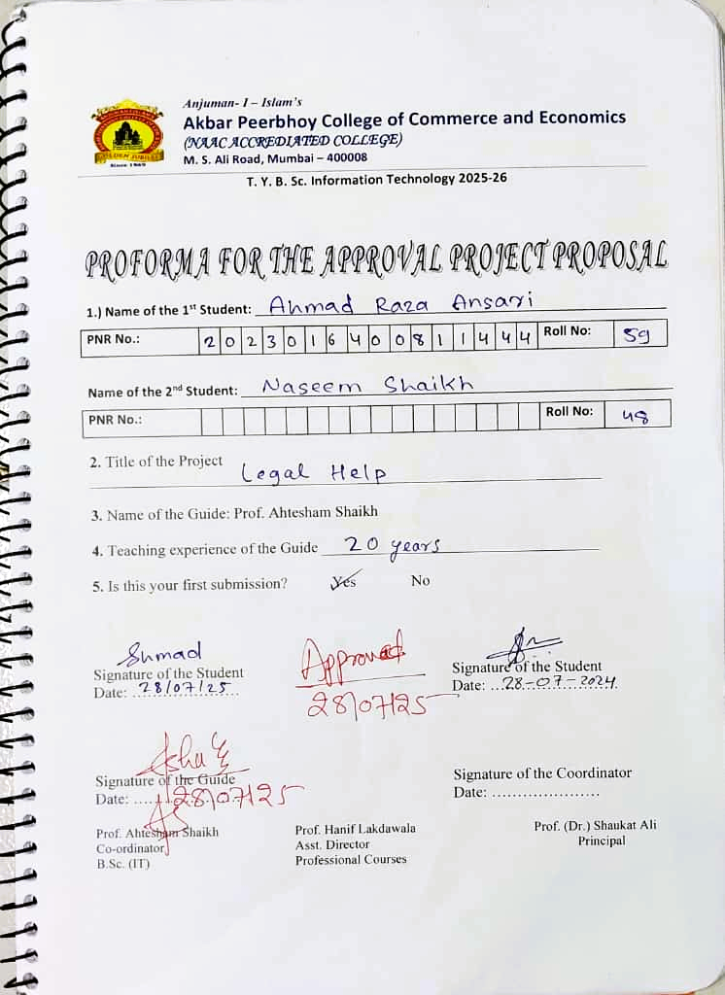

**AKBAR PEERHOY COLLEGE OF COMMERCE AND ECONOMICS**

*(Affiliated to University of Mumbai)*

MUMBAI-MAHARASHTRA-400008

**DEPARTMENT OF INFORMATION TECHNOLOGY**



**CERTIFICATE**

This is to certify that the project entitled, **"LEGAL HELP"**, is bonafied work of **AHMAD RAZA ANSARI** bearing Seat No:  **and NASEEM SHAIKH** bearing Seat No: submitted in partial fulfilment of the requirements for the award of degree of **BACHELOR OF SCIENCE in INFORMATION TECHNOLOGY** from **University of Mumbai.**

Internal Guide Coordinator

**External Examiner**

Date: College Seal

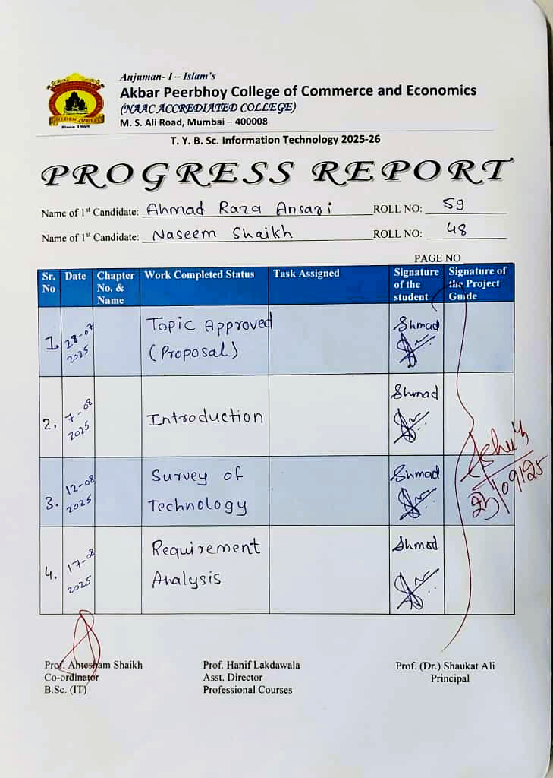

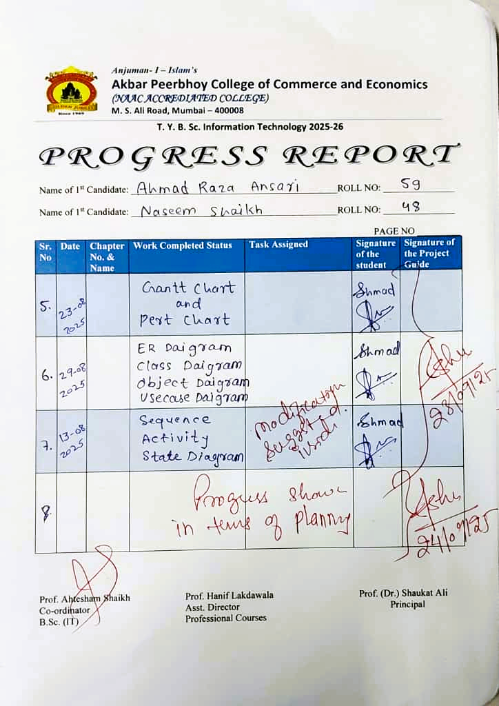

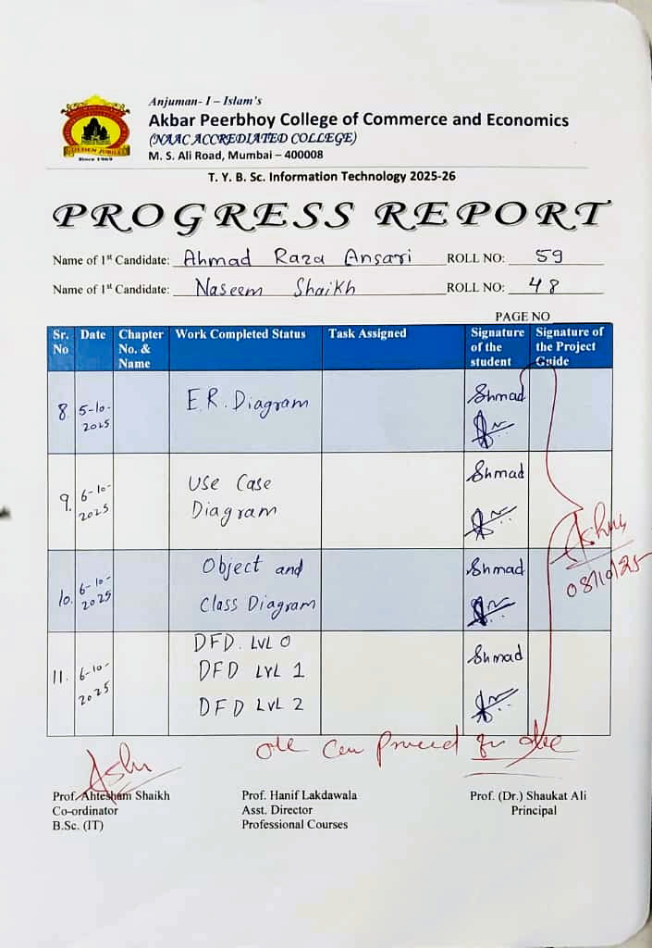

**ABSTRACT**

Access to legal knowledge remains a challenge for many citizens due to the complexity of laws and legal terminology. The Legal Help project addresses this gap by developing a mobile application that integrates Artificial Intelligence (AI) with a structured repository of Indian laws. The system enables users to browse categorized laws, query an AI-powered chatbot, access legal dictionary terms with simplified AI explanations, and utilize emergency helpline numbers.

The application is built using Flutter for the frontend, with a backend AI-driven Retrieval-Augmented Generation (RAG) model that employs a Vector Database to retrieve relevant law sections and generate human-readable explanations. Users can interact via text or speech input, bookmark legal sections, and receive personalized daily law suggestions.

By simplifying legal jargon, providing contextual AI explanations, and offering direct access to rights, laws, and support services, the system enhances legal awareness and accessibility for the general public. This project demonstrates the potential of combining AI and mobile technology to empower citizens with practical, user-friendly legal assistance.

Keywords: Legal Help, Artificial Intelligence, RAG, Vector Database, Flutter, Indian Laws, Legal Awareness.

**ACKNOWLEDGEMENT**

We would like to express our heartfelt gratitude to our project guides, **Prof. Ahtesham Shaikh** and **Prof. Shahid Parvez**, for their invaluable guidance, encouragement, and support throughout the course of this project, ***“Legal Help”***. Their expert insights, constructive feedback, and constant motivation have been instrumental in the successful completion of this work.

We are also thankful to our faculty members and our institution for providing the necessary resources, technical infrastructure, and academic environment that enabled us to undertake and complete this project effectively.

Finally, we, **Ahmad Raza** and **Naseem Shaikh**, sincerely appreciate the collaborative effort, dedication, and teamwork that went into bringing this project to fruition.

**DECLARATION**

I here by declare that the project entitled, "**Legal Help**" done at **Akbar Peerbhoy College of Commerce and Economics**, has not been in any case duplicated to submit to any other university for the award of any degree. To the best of my knowledge other than me, no one has submitted to any other university.

The project is done in partial fulfillment of the requirements for the award of degree of **BACHELOR OF SCIENCE (INFORMATION TECHNOLOGY)** tobe submitted as final semester project as part of our curriculum.

**Name and Signature of the Student**

**Name and Signature of the Student**

**TABLE OF CONTENTS**

|  |  |  |
| --- | --- | --- |
| **Sr. No.** | **Topic** | **Page No.** |
| **Chapter 1** | **Introduction** | **12** |
| 1.1 | Background | 12 |
| 1.2 | Objectives | 12 |
| 1.3 | Purpose | 13 |
| 1.4 | Scope | 14 |
| 1.5 | Applicability | 15 |
| 1.6 | Achievements | 17 |
| 1.7 | Organization of report | 18 |
| **Chapter 2** | **Survey of Technology** | **20** |
| 2.1 | Overview of existing technology | 20 |
| 2.2 | Details of all related technologies | 21 |
| 2.3 | Technology available in chosen area | 23 |
| 2.4 | Student selected this technology | 25 |
| **Chapter 3** | **Requirement and Analysis** | **27** |
| 3.1 | Problem Definition | 27 |
| 3.2 | Requirement Specification | 28 |
| 3.2.1 | Functional Requirements | 28 |
| 3.2.2 | Non-functional Requirements | 29 |
| 3.3 | Planning and Scheduling | 31 |
| 3.3.1 | Gantt Chart | 31 |
| 3.4 | Software and Hardware Requirements | 32 |
| 3.4.1 | Software Requirements | 32 |
| 3.4.2 | Hardware Requirements | 33 |
| 3.5 | Feasibility Study | 33 |
| 3.5.1 | Technical Feasibility | 33 |
| 3.5.2 | Economic Feasibility | 34 |
| 3.5.3 | Operational Feasibility | 34 |
| 3.6 | Fact Finding Technique | 34 |
| 3.6.1 | Observation | 34 |
| 3.6.2 | Record Review | 35 |
| 3.6.3 | Questionnaires | 35 |
| 3.6.4 | Interview | 35 |
| **Chapter 4** | **System Design** | **36** |
| 4.1 | Design Diagrams | 36 |
| 4.1.1 | E-R Diagram | 36 |
| 4.1.2 | Class Diagram | 38 |
| 4.1.3 | Object Diagram | 39 |
| 4.1.4 | Use Case Diagram | 41 |
| 4.1.5 | Sequence Diagram | 42 |
| 4.1.6 | Activity Diagram | 49 |
| 4.1.7 | Data Flow Diagram with 3 Level | 50 |
| 4.2 | Module Design | 52 |
| 4.2.1 | Module Names with description | 52 |
| 4.2.2 | Module Functionality | 55 |
| 4.3 | Schema Design | 56 |
| 4.3.1 | Database Design | 56 |
| 4.4 | Data Integrity and Constraints | 57 |
| 4.4.1 | Data Integrity | 57 |
| 4.4.2 | Data Constraints | 57 |
| 4.5 | User Interface Design | 58 |
| 4.5.1 | Design Consideration | 58 |
| 4.5.2 | UI/UX Design | 60 |
| 4.6 | Security Issues | 67 |
| 4.6.1 | Security Issues related to project | 67 |
| 4.6.2 | Security Policy and Plan | 67 |
| 4.7 | Cost Estimation | 68 |

# **Chapter 1 Introduction**

## Background

In India, a large portion of the population remains unaware of their fundamental rights and the legal provisions that protect them. The complexity of legal language, limited access to reliable legal resources, and the high cost of professional consultation often discourage citizens from seeking proper legal guidance. As a result, people tend to depend on unverified online information or informal advice, which may lead to misunderstanding of laws and misuse of rights.

To overcome these challenges, the **Legal Help** project has been conceptualized as a digital platform that simplifies access to Indian laws and legal guidance. The system aims to deliver authentic and easily understandable information through an intuitive mobile and web application. It provides categorized legal content, an **AI-driven chatbot** capable of answering user queries, and a **lawyer appointment system** that connects users with verified professionals.

By integrating modern technologies such as **Flutter**, **Node.js**, **MongoDB**, and **Retrieval-Augmented Generation (RAG)**-based artificial intelligence, the platform ensures intelligent, fast, and context-aware responses to user questions. The project’s ultimate goal is to **promote legal literacy** among citizens and empower them to make informed decisions regarding their rights and responsibilities.

## Objectives

The main objective of the **Legal Help** project is to create an intelligent, user-friendly digital platform that provides simplified legal awareness and professional assistance to citizens. The system aims to bridge the gap between people and the legal framework by integrating technology with real-time information access.

The specific objectives of the projectare:

1. **To provide categorized access to legal information** – Present laws and acts under clearly defined categories such as Constitutional, Criminal, Civil, and Cyber laws for easy understanding.
2. **To implement an AI-powered legal chatbot** – Enable users to ask legal questions and receive accurate, section-based explanations using Retrieval-Augmented Generation (RAG) technology.
3. **To develop a lawyer appointment and consultation module** – Allow users to find, contact, and consult verified lawyers through the application.
4. **To include a legal dictionary** – Offer simplified definitions and explanations of legal terms to enhance legal literacy.
5. **To provide personalized law suggestions** – Recommend relevant legal topics or sections to users based on their interests or previous searches.
6. **To offer access to court judgments** – Allow users to explore judicial decisions for educational and reference purposes.
7. **To promote legal awareness and empowerment** – Encourage citizens to understand their rights, duties, and legal remedies independently.

## 1.3 Purpose

The primary purpose of the Legal Help project is to bridge the significant gap between citizens and the legal system through the use of modern technology. In a country like India, where legal awareness among common people is still limited, there exists a pressing need for a platform that can make legal information simple, accessible, and interactive. Many individuals struggle to understand legal terminologies, find relevant sections of law, or identify the appropriate legal procedures for their problems. The **Legal Help** application addresses this need by providing a single digital solution that integrates legal information, artificial intelligence, and professional consultation.

The system is designed to serve both **citizens** and **lawyers**. For citizens, it offers instant access to categorized laws, AI-based query assistance, and the ability to connect with legal experts. For lawyers, it provides a professional space to manage client interactions, appointments, and share their expertise. By merging these two user groups in one digital environment, the platform encourages transparency, reliability, and trust in online legal consultation.

From a technological perspective, the project aims to implement an intelligent and context-aware **AI chatbot** powered by **Retrieval-Augmented Generation (RAG)**

architecture, enabling users to ask questions and receive detailed explanations based on real legal data. The integration of **Flutter** ensures that the application is available on both Android and web platforms, while **Node.js** and **MongoDB** provide a secure and scalable backend infrastructure.

Furthermore, the project emphasizes educational and social objectives. It seeks to promote legal literacy, especially among students, rural citizens, and individuals who cannot afford direct legal consultation. By including features such as a legal dictionary, court judgment access, and personalized law suggestions, the system not only answers immediate legal questions but also helps users continuously learn about their rights and responsibilities.

In essence, the purpose of this project is not limited to offering legal advice but to create a digital ecosystem for legal empowerment. It encourages citizens to make informed decisions, supports lawyers in reaching more clients efficiently, and contributes to a society that is more aware, confident, and responsible regarding legal matters.

# 1.4 Scope

The scope of the **Legal Help** project extends to the design and development of an intelligent digital platform that provides users with comprehensive legal assistance and information in a simplified and organized manner. The system is intended to benefit both **general users** (citizens) and **legal professionals** (lawyers) by offering a centralized application that promotes awareness, accessibility, and efficiency in legal interactions.

The project encompasses a wide range of features, including access to categorized laws, an AI-powered chatbot for legal queries, a lawyer appointment module, and tools for learning such as a legal dictionary and court judgment access. The system ensures that even users without legal expertise can easily navigate and understand laws relevant to their needs.

**User Groups and Their Scope of Interaction**

1. **General Users (Citizens):**

* Can register and log in to the application.
* Access categorized laws such as Constitutional, Criminal, Civil, and Cyber Laws.
* Interact with an AI chatbot to ask legal questions and receive section-based explanations.
* Bookmark or save legal sections and judgments for future reference.
* Receive **daily personalized law suggestions** to improve their awareness.
* Book appointments with verified lawyers for consultation.

1. **Lawyers (Legal Professionals):**

* Register as verified professionals through authentication and profile verification.
* Manage client requests, appointments, and case updates through the platform.
* Access legal information and judgments for professional reference.
* Use the AI chatbot to get quick legal explanations and suggestions.

1. **System Features Within Scope**

* **User Authentication & Profile Management:** Secure registration, login, and role-based access for users and lawyers.
* **AI-Based Legal Chatbot:** Uses Retrieval-Augmented Generation (RAG) to provide instant legal answers and explanations.
* **Categorized Law Access:** Organized database of laws under various categories for easy exploration.
* **Lawyer Appointment Module:** Allows booking, scheduling, and managing appointments with verified lawyers.
* **Legal Dictionary:** Simplified explanations of legal terms and terminologies.
* **Saved Sections & Personalized Suggestions:** Enables bookmarking and tailored law recommendations.
* **Court Judgment Access:** Provides access to previous judgments for educational and reference purposes.

# 1.5 Applicability

The Legal Help project has wide applicability across various sectors of society, education, and the legal domain. Its design allows it to serve as both an educational tool for legal learning and a practical platform for obtaining legal guidance. By combining artificial intelligence with legal data, the system ensures that individuals from different backgrounds can benefit from accurate, accessible, and comprehensible legal information.

**1. Educational Institutions**

The system can be effectively used in colleges, universities, and law institutes as an **interactive learning platform**.

* Law students can use it to quickly understand sections of law, terminologies, and judicial judgments.
* It can serve as a **supplementary digital library** where learners access categorized legal data and ask queries to the AI chatbot for better conceptual clarity.
* It can also be used in non-law programs to spread awareness about basic rights and responsibilities among students.

**2. General Public**

The application is primarily aimed at empowering the **common citizen** who may not have easy access to legal experts.

* Users can ask questions, learn about laws, and understand how specific sections apply to their situations.
* It can be used as a **personal legal guide** to promote legal literacy and reduce dependency on unreliable sources of information.
* The personalized law suggestion and bookmarking features help users continuously enhance their knowledge in an engaging manner.

**3. Legal Professionals and Law Firms**

The platform provides a digital space for **lawyers and advocates** to connect with clients efficiently.

* Lawyers can use the system to manage client appointments, consultations, and case records.
* The AI chatbot and categorized legal database can assist them in quickly referring to relevant sections or judgments during case preparation.
* It helps legal professionals enhance their visibility and accessibility through verified online profiles.

**4. Government and NGOs**

The project can be extended to support **legal awareness campaigns** and **citizen empowerment programs** initiated by government agencies or non-governmental organizations.

* NGOs working on social justice, women’s rights, or rural development can use the platform to spread basic legal education.
* It can support government initiatives focused on **digital India** and **legal literacy missions** by providing a ready-to-use digital infrastructure.

#### 1.6 Achievements

The Legal Help project has successfully accomplished several milestones that demonstrate its functionality, technological integration, and contribution to improving legal awareness among citizens. These achievements reflect both technical implementation and practical usability:

1. **AI-Powered Legal Chatbot**

* Developed a Retrieval-Augmented Generation (RAG) based chatbot capable of answering law-related queries with context-aware explanations.
* Supports both text and voice input, making it accessible and user-friendly.
* Provides references to relevant legal sections and acts for accurate guidance.

1. **Categorized Law Access**

* Implemented a structured database of Indian laws organized under Constitutional, Criminal, Civil, Cyber, and other domains.
* Allows users to search, browse, and bookmark sections efficiently for quick reference.

1. **Lawyer Appointment and Consultation Module**

* Built a system to enable users to view verified lawyer profiles, book appointments, and track case progress.
* Allows lawyers to manage client interactions and consultations digitally.

1. **Legal Dictionary**

* Developed a comprehensive legal dictionary with simplified explanations for complex legal terms.
* Helps users and students understand legal terminology without prior legal knowledge.

1. **Saved Sections & Personalized Law Suggestions**

* Introduced bookmarking for important legal sections and personalized daily law suggestions.
* Promotes continuous learning and legal awareness tailored to the user’s interests.

1. **Court Judgment Access**

* Integrated access to judicial decisions from various courts for reference and educational purposes.
* Users can search, view, and save judgments to support self-learning or case research.

1. **Cross-Platform Interface**

* Developed the application using Flutter for Android and web platforms, ensuring responsive and intuitive navigation.
* Provides a smooth user experience for both citizens and legal professionals.

1. **Secure and Scalable Backend**

* Implemented Node.js and Express backend with MongoDB for efficient data storage and retrieval.
* Integrated AI components with Pollination API and Qdrant for semantic search and intelligent, context-aware responses.

#### 1.7 Organization of Report

The Legal Help project report is organized systematically to provide a clear understanding of the project’s objectives, methodology, design, implementation, and outcomes. The structure is as follows:

Chapter 1: Introduction

* Provides the background of the project, highlighting the need for legal awareness among citizens.
* Outlines the objectives, purpose, scope, applicability, and achievements of the Legal Help system.
* Explains the overall organization of the report to guide the reader.

Chapter 2: Survey of Technology

* Reviews existing technologies related to legal assistance and awareness applications.
* Provides a detailed study of the technologies used in this project, including Flutter, Node.js, MongoDB, Pollination AI, and Qdrant.
* Explains why the selected technologies were chosen to achieve the project objectives effectively.

Chapter 3: Requirement and Analysis

* Defines the problem statement addressed by the project.
* Specifies functional and non-functional requirements of the system.
* Includes planning and scheduling aspects such as the Gantt chart.
* Lists software and hardware requirements and conducts feasibility studies (technical, economic, and operational).
* Describes fact-finding techniques like observation, record review, questionnaires, and interviews.

Chapter 4: System Design

* Presents the design methodology and architectural details of the system.
* Includes ER diagrams, use case diagrams, sequence diagrams, activity diagrams, component diagrams, and deployment diagrams.
* Explains system workflows, interactions between users and AI, and module integration.

Chapter 5: Implementation and Testing

* Describes the coding and development process.
* Explains the implementation of different modules such as AI chatbot, lawyer appointment system, and legal database.
* Details system testing, bug fixes, and performance evaluation to ensure reliability.

Chapter 6: Conclusion and Future Scope

* Summarizes the outcomes and accomplishments of the project.
* Discusses potential enhancements, scalability options, and the future direction of the Legal Help system.
* Highlights the impact of the project on legal awareness and digital empowerment.

# **Chapter 2 Survey of Technologies**

#### 2.1 Overview Of Existing Technology

In recent years, digital platforms and mobile applications have increasingly been used to provide legal assistance, information, and consultation services. These technologies aim to make legal knowledge more accessible to the general public, improve interaction between citizens and legal professionals, and reduce dependency on intermediaries or informal sources of information.

1. **Legal Information Websites**

* Websites such as IndiaCode, VakilSearch, and Legal Service India provide access to laws, acts, and legal guidelines.
* While these platforms offer comprehensive legal content, they often lack interactive assistance and personalized support, which makes it difficult for non-expert users to navigate complex legal texts.

1. **Legal Aid Mobile Applications**

* Applications like LawRato, MyAdvo, and PathLegal enable users to consult lawyers, book appointments, and receive online legal advice.
* Most of these apps primarily focus on connecting clients to lawyers rather than providing educational tools or AI-powered guidance on legal rights and laws.

1. **Chatbots and AI-Based Legal Assistants**

* AI-driven chatbots have started emerging to answer simple legal questions.
* Existing chatbots are generally limited in scope, responding with generic answers or directing users to external resources without providing context-based explanations.

1. **Digital Libraries and Legal Databases**

* Platforms like SCC Online and Manupatra provide access to case law, judgments, and legal journals.
* These databases are designed for legal professionals and researchers and are often subscription-based, limiting accessibility for the general public.

**Limitations of Existing Technologies**

* **Complexity:** Legal databases and websites often contain unstructured and technical content, difficult for laypersons to comprehend.
* **Limited Interactivity:** Few existing solutions offer interactive AI-powered guidance or personalized suggestions.
* **Accessibility Issues:** Many apps are either web-only or require technical knowledge, reducing accessibility for rural or non-tech-savvy users.
* **Fragmented Services:** No single platform currently integrates legal education, AI-based guidance, lawyer consultation, and judgment access comprehensively.

**2.2 Details of All Related Technologies**

The Legal Help project integrates several modern technologies to create a seamless, efficient, and intelligent legal assistance platform. These technologies span frontend and backend development, database management, and AI-based solutions. Each technology is selected based on its capability to meet the functional and non-functional requirements of the system.

**1. Flutter (Frontend Development)**

* **Overview:** Flutter is an open-source UI toolkit developed by Google for building natively compiled applications for mobile, web, and desktop from a single codebase.
* **Purpose in Project:**
  + Enables cross-platform compatibility, allowing the Legal Help app to run on Android devices and web browsers without separate codebases.
  + Provides a rich set of pre-designed widgets, ensuring a responsive and visually appealing interface.
  + Supports fast development cycles and hot-reload functionality for quicker testing and debugging.
* **Advantages:** Efficient, scalable, consistent UI across platforms, and reduces development time.

**2. Node.js with Express (Backend Development)**

* **Overview:** Node.js is a JavaScript runtime built on Chrome's V8 engine, while Express is a minimal web framework for Node.js that simplifies server-side development.
* **Purpose in Project:**
  + Manages API endpoints for user authentication, lawyer appointment management, legal data retrieval, and chatbot interactions.
  + Provides asynchronous, event-driven architecture suitable for handling multiple user requests efficiently.
* **Advantages:** High performance, scalable, easy integration with databases and frontend frameworks.

**3. MongoDB (Database Management)**

* **Overview:** MongoDB is a NoSQL database that stores data in flexible, JSON-like documents.
* **Purpose in Project:**
  + Stores structured and unstructured legal data, including laws, case judgments, user profiles, and lawyer information.
  + Allows easy querying and indexing for fast search functionality, which is critical for AI-powered legal queries.
* **Advantages:** Flexible schema, high scalability, support for large datasets, and integration with Node.js through Mongoose ORM.

**4. Pollination AI API (AI Integration)**

* **Overview:** Pollination AI provides natural language processing capabilities for building AI chatbots capable of understanding and generating human-like responses.
* **Purpose in Project:**
  + Powers the legal chatbot to answer user queries intelligently.
  + Supports text and voice-based interactions with context-aware legal explanations.
* **Advantages:** Reduces response time, provides interactive guidance, and enhances user engagement through conversational AI.

**5. Qdrant (Vector Search & Semantic Embeddings)**

* **Overview:** Qdrant is a vector database optimized for storing and searching embeddings used in AI-based semantic search and similarity tasks.
* **Purpose in Project:**
  + Stores vector embeddings of legal documents, judgments, and laws for semantic search.
  + Works with the RAG (Retrieval-Augmented Generation) architecture to provide precise, context-aware answers to user queries.
* **Advantages:** Fast semantic search, scalable vector storage, accurate retrieval of relevant legal content.

**6. RAG (Retrieval-Augmented Generation) Architecture**

* **Overview:** RAG combines a knowledge retrieval system with generative AI models to provide contextually accurate responses.
* **Purpose in Project:**
  + Ensures that AI responses are backed by actual legal data rather than generic answers.
  + Allows the chatbot to reference relevant legal sections, acts, and case judgments dynamically.
* **Advantages:** Increases accuracy, reduces hallucinations in AI responses, and integrates knowledge retrieval with natural language generation.

# 2.3 Technology Available In Chosen Area

The Legal Help project relies on a set of technologies that are widely available, mature, and suitable for building intelligent legal assistance systems. This section examines the availability, relevance, and applicability of each technology in the context of the project.

**1. Flutter (Cross-Platform Development)**

* **Availability:** Flutter is an open-source framework supported by Google with a large global developer community.
* **Relevance:** Its cross-platform capabilities make it ideal for building apps that run on both Android devices and web browsers, ensuring broader accessibility.
* **Applicability:** The Legal Help app can be deployed efficiently without maintaining separate codebases for mobile and web platforms. Flutter’s rich widget library allows easy implementation of user-friendly interfaces for browsing laws, interacting with AI chatbots, and booking lawyer appointments.

**2. Node.js with Express (Backend Development)**

* **Availability:** Node.js is a widely used, open-source runtime environment with extensive documentation and community support. Express framework provides simplicity and modularity for building RESTful APIs.
* **Relevance:** Node.js supports asynchronous processing, which is crucial for handling multiple user requests in real-time, such as AI chatbot queries and lawyer booking.
* **Applicability:** The backend can efficiently manage user authentication, legal data retrieval, appointment scheduling, and AI integration, making it suitable for a scalable, high-performance system.

**3. MongoDB (Database Management)**

* **Availability:** MongoDB is a leading NoSQL database with commercial and community editions available worldwide.
* **Relevance:** Its flexible schema is ideal for storing diverse legal data types, including structured law sections, unstructured case judgments, and user interactions.
* **Applicability:** MongoDB allows rapid development, high scalability, and easy integration with Node.js, making it a practical choice for storing and retrieving large volumes of legal information.

**4. Pollination AI API (Artificial Intelligence Integration)**

* **Availability:** Pollination AI is a cloud-based AI service offering NLP and chatbot capabilities through an accessible API.
* **Relevance:** Provides a pre-trained AI model capable of understanding legal queries, generating human-like responses, and handling conversational interactions.
* **Applicability:** Enables the Legal Help chatbot to deliver accurate, context-aware answers to users, enhancing interactivity and user engagement.

**5. Qdrant (Vector Database for Semantic Search)**

* **Availability:** Qdrant is available as an open-source vector database or cloud service, widely used for AI-based semantic search and embedding storage.
* **Relevance:** Its vector search capabilities allow accurate retrieval of legal information based on semantic similarity rather than simple keyword matching.
* **Applicability:** Works in tandem with RAG architecture to enable precise, context-aware responses in the AI chatbot, improving the quality of legal guidance provided to users.

**6. Retrieval-Augmented Generation (RAG) Architecture**

* **Availability:** RAG is a recognized architecture in modern AI and NLP research, with open-source implementations and libraries available for integration.
* **Relevance:** Combines retrieval-based knowledge access with generative AI, ensuring responses are both accurate and contextually relevant.
* **Applicability:** Essential for the Legal Help system to provide reliable answers, reference actual legal documents, and reduce the risk of AI-generated misinformati

**2.4 Student Selected This Technology**

The selection of technologies for the Legal Help project was carried out after evaluating multiple alternatives across mobile development, backend frameworks, databases, artificial intelligence platforms, and supporting services. The chosen stack aligns with the project objectives of creating a scalable, accessible, and intelligent legal assistance platform for citizens.

Flutter (Mobile App Development)

* Chosen because it allows cross-platform deployment from a single codebase, ensuring that both Android and iOS users can access the app without separate development efforts.
* Its rich widget library supports building a responsive and user-friendly interface, crucial for browsing categorized laws, saving legal sections, and accessing helplines.
* Flutter’s hot reload accelerates the development and debugging process, allowing for rapid iterations.

Node.js with Express (Backend Services)

* Selected due to its non-blocking, event-driven architecture, which is ideal for handling chatbot requests, authentication, and real-time communication.
* Provides a lightweight yet powerful REST API layer for connecting the mobile app with MongoDB, Qdrant, and AI APIs.
* Faster to implement compared to heavy frameworks like Django or Spring Boot.

MongoDB Atlas (Cloud Database)

* Adopted for its flexibility in schema design, allowing easy storage of diverse datasets like user profiles, bookmarks, and chat histories.
* Cloud deployment through MongoDB Atlas ensures security, scalability, and global accessibility, which are vital for user-based applications.

Qdrant (Vector Database for RAG)

* Specifically selected to power the Retrieval-Augmented Generation (RAG) model by storing embeddings of legal texts and nabling semantic similarity search.
* Its open-source nature ensures cost-effectiveness and smooth integration with AI APIs compared to costly alternatives like Pinecone.
* Critical for retrieving relevant law sections in response to user queries.

Pollination AI API (LLM Integration)

* Selected as the AI engine of the Legal Help chatbot, enabling context-aware, legally grounded answers.
* Chosen because it is cost-effective, developer-friendly, and supports RAG pipelines efficiently.

Speech-to-Text Services (Google STT + Whisper)

* Chosen to provide voice-based query support, making the app inclusive for citizens who prefer speaking over typing.
* Google STT ensures multilingual support for Indian languages, while Whisper ensures robustness in noisy conditions.

JSON Assets (Offline Legal Data Storage)

* Adopted for storing laws and legal sections within the app, ensuring offline access without internet dependency.
* Its lightweight nature makes it suitable for fast access and structured categorization of large legal documents.

Helpline Integration (Citizen-Centric Feature)

* Included to extend the app’s usefulness beyond information retrieval, enabling **direct citizen support** in emergencies.
* Categorization of helplines (Women, Children, Cyber, Railway, etc.) adds value compared to generic helpline apps

# **Chapter 3 Requirements and Analysis**

## Problem Definition

In India, a significant portion of the population remains unaware of their legal rights, obligations, and the procedures required to seek justice. This lack of awareness often leads to misuse, exploitation, and inability to effectively navigate the legal system. The complexity of legal language, scattered sources of information, and high costs associated with professional legal advice further exacerbate the problem.

Existing solutions, such as legal websites, apps, and databases, provide limited support:Many platforms focus only on connecting users with lawyers, without offering educational content or interactive guidance.

* Legal databases and online resources often contain technical and unstructured information, making it difficult for common citizens to understand.
* AI-based chatbots, where available, usually provide generic answers without referencing actual legal documents, reducing their reliability.

The primary problem addressed by the **Legal Help** project is the **lack of a unified, accessible, and interactive platform that combines legal education, AI-driven guidance, and professional consultation**. Citizens require a system that:

1. Simplifies the understanding of legal rights and responsibilities.
2. Provides reliable and context-aware AI assistance for law-related queries.
3. Enables direct, verified consultation with lawyers.
4. Offers structured access to legal documents, judgments, and simplified legal terminologies.

**Goal:**  
To develop an intelligent digital platform that bridges the gap between citizens and the legal system, enhances legal literacy, and empowers users to make informed decisions without depending on unverified sources or intermediaries.

## Requirement Specification

**3.2.1 Functional Requirements**

Functional requirements describe the specific behaviors, features, and functions that the Legal Help system must provide to meet the needs of its users. These requirements focus on what the system should do to achieve its objectives of legal awareness, AI assistance, and lawyer consultation.

## 1. User Authentication and Profile Management

* The system shall allow users and lawyers to register and log in securely.
* Users shall be able to create, update, and manage their profiles, including personal details and preferences.
* Lawyers shall be able to verify their professional credentials during registration.

## 2. Categorized Law Access

* The system shall provide access to Indian laws categorized under Constitutional, Criminal, Civil, Cyber, and other legal domains.
* Users shall be able to search, browse, and bookmark laws for future reference.

## 3. AI-Powered Legal Chatbot

* The system shall provide an AI chatbot capable of understanding user queries and generating context-aware responses using RAG architecture.
* The chatbot shall accept both text and voice inputs.
* The chatbot shall reference actual legal sections, acts, and case judgments when providing answers.

## 4. Lawyer Appointment and Consultation Module

* Users shall be able to search and view verified lawyer profiles.
* The system shall allow users to book appointments and track consultation or case progress.
* Lawyers shall be able to manage client interactions, appointments, and case updates digitally.

## 5. Legal Dictionary

* The system shall provide a dictionary containing legal terms with simplified explanations.
* Users shall be able to search and browse terms easily.

## 6. Saved Sections and Personalized Law Suggestions

* Users shall be able to bookmark important laws, judgments, and legal articles.
* The system shall provide daily personalized law suggestions based on user activity and interests.

## 7. Court Judgment Access

* The system shall allow users to search, view, and bookmark court judgments from various courts.
* Users shall be able to reference these judgments for learning or case research.

## 8. Notification and Updates

* The system shall provide notifications for booked appointments, lawyer replies, or updates in bookmarked laws.

## 9. Security and Access Control

* The system shall implement role-based access control to differentiate between general users and lawyers.
* All sensitive user data shall be stored securely in the database.

**3.2.2 Non-Functional Requirements**

Non-functional requirements define the quality attributes, system performance, and operational constraints of the Legal Help system. These requirements ensure that the platform is reliable, efficient, and provides a good user experience.

**1. Performance Requirements**

* The system shall respond to user queries, including AI chatbot interactions, within 2–5 seconds.
* Law searches, judgment retrievals, and data filtering shall be executed efficiently to ensure minimal latency.
* The system shall support concurrent access by multiple users without significant performance degradation.

**2. Reliability and Availability**

* The system shall have an uptime of at least 99% to ensure accessibility to users at all times.
* Backup mechanisms shall be implemented to prevent data loss in case of system failure.
* Error-handling mechanisms shall ensure that unexpected failures do not crash the application.

**3. Scalability**

* The system shall be scalable to accommodate an increasing number of users, legal documents, and AI query requests.
* Both backend and database services shall allow horizontal and vertical scaling to handle future growth.

**4. Security Requirements**

* User authentication shall be secure, and passwords shall be encrypted.
* Role-based access control shall ensure that only authorized users (lawyers, admins) can access sensitive features.
* Data transmission between client and server shall be encrypted using HTTPS/SSL protocols.

**5. Usability and Accessibility**

* The system shall provide an intuitive, user-friendly interface suitable for both tech-savvy and non-tech-savvy users.
* Text and voice input options shall be available for the AI chatbot to accommodate different user preferences.
* The application shall support cross-platform access on Android and web browsers.

**6. Maintainability**

* The system code shall be modular and well-documented to facilitate future maintenance and updates.
* Database structures shall allow easy modifications and additions to legal content without affecting existing functionality.

**7. Portability**

* The application shall be compatible with multiple devices and operating systems, ensuring accessibility to a wide audience.
* Updates to the application shall be deployable without requiring significant downtime.

**8. Compliance**

* The system shall adhere to standard data protection and privacy regulations applicable to user data.
* Legal content shall be referenced accurately from authentic sources to maintain information reliability.

## Planning and Scheduling

Successful completion of the **Legal Help** project required systematic planning and time-bound execution. The project was divided into phases, with each phase addressing specific activities, deliverables, and milestones.

**3.3.1 Gantt Chart**

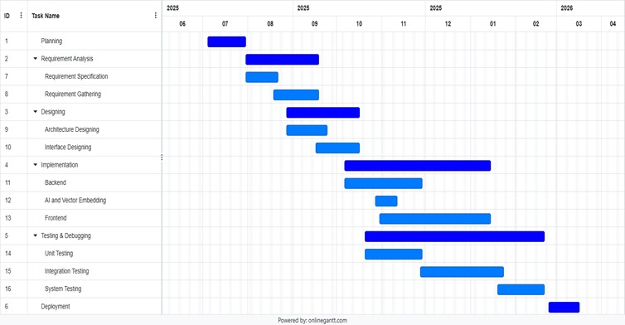

## Software and Hardware Requirement

For the successful development and execution of the Legal Help project, both software tools and hardware resources were identified. These requirements ensure that the system performs efficiently during development, testing, and deployment.

**3.4.1 Software Requirement**

**1. Operating System**

* Windows 10/11, macOS, or Linux for development and deployment environments.

**2. Frontend Development Tools**

* Flutter SDK: To build cross-platform mobile and web applications.
* Dart Programming Language: Used for coding in Flutter.
* Visual Studio Code / Android Studio: Integrated development environments (IDEs) for coding, debugging, and testing Flutter applications**.**

**3. Backend Development Tools**

* Node.js: JavaScript runtime environment for server-side development.
* Express Framework: Provides APIs and server management for handling requests and responses.
* Postman / Thunder Client: Tools for testing API endpoints.

**4. Database Management**

* MongoDB: NoSQL database for storing user data, legal content, case information, and AI embeddings.
* MongoDB Compass / Robo 3T: GUI tools for managing and visualizing the database.

**5. AI & Semantic Search Integration**

* Pollination AI API: To implement AI-powered chatbot and natural language understanding.
* Qdrant: Vector database for semantic search and context-aware retrieval of legal documents**.**

**6. Version Control and Collaboration Tools**

* Git: Version control system to manage codebase revisions.
* GitHub / GitLab: Platforms for remote repository hosting, team collaboration, and backup**.**

**7. Browser and Testing Tools**

* Modern browsers (Google Chrome, Mozilla Firefox) for web testing.
* Flutter DevTools for debugging and performance monitoring.

**8. Additional Tools**

* Postman: For API testing and validation.
* Visual Studio Code Extensions: Plugins for linting, formatting, and debugging.

**3.4.2 Hardware Requirement:**

1. **Development Machine (Laptop/PC):**

Processor: Intel i5 (or equivalent AMD Ryzen) or higher

RAM: Minimum 8 GB (Recommended 16 GB for AI integrations)

Storage: 512 GB SSD or higher

1. **Mobile Devices (for testing):**

Android smartphone (Android 9.0 or above)

1. **Network Requirements:**

Stable internet connection (minimum 10 Mbps) for cloud APIs and Firebase sync.

* 1. **Feasibility Study**

Before developing the Legal Help application, a feasibility study was carried out to evaluate whether the project could be successfully implemented with the available resources, technology, and constraints. The study covered three aspects: Technical, Economic, and Operational feasibility.

**3.5.1 Technical Feasibility**

* The required technologies (Flutter, Node and Express, Mongo DB, Vector Databases, AI APIs, and Speech-to-Text services) are well-established and readily available.
* Development tools such as Visual Studio Code, Android Studio, and GitHub provide robust support for mobile app development and version control.
* AI APIs (like OpenAI GPT) and vector search engines (like Pinecone/FAISS) can be integrated smoothly with the backend.
* Cross-platform development with Flutter ensures that both Android and iOS devices can run the application efficiently.
* Hardware requirements (standard laptops with ≥8GB RAM) are sufficient for development and testing.

**3.5.2 Economic Feasibility**

* Most required tools are open-source or free to use (Flutter SDK, FAISS, Firebase free tier, Whisper, etc.).
* Some APIs (like advanced AI models or Pinecone cloud) may require subscription, but costs remain within a reasonable student project budget.
* Using cross-platform development (Flutter) reduces development cost and time compared to maintaining separate Android/iOS codebases.
* Hosting and database services (Firebase, MongoDB Atlas free tier) can be utilized at minimal or no cost during the project phases.

**3.5.3 Operational Feasibility**

* The system addresses a real and significant problem (lack of legal awareness among citizens).
* The application has been designed with simplicity and usability in mind, so non-technical users can easily browse laws, ask queries, and access helplines.
* Voice input and AI explanations make the app inclusive for users with different literacy levels.
* Students (Ahmed Raza and Naseem Shaikh) possess the necessary technical skills and guidance from faculty to complete the project successfully.
* The system can be further improved or scaled in the future, making it adaptable for long-term use.
  1. **Fact Finding Technique**

To properly define requirements and design an effective solution, various fact-finding techniques were used. These techniques helped in understanding the existing gaps in legal awareness and identifying user needs for the **Legal Help** system.

**3.6.1 Observation**

* Direct observation of how people currently seek legal information was carried out.
* It was noticed that most citizens rely on search engines, social media posts, or word-of-mouth advice, which often leads to incomplete or incorrect information.
* This observation confirmed the need for a simplified, centralized legal information platform.

**3.6.2 Record Review**

* Existing resources such as online legal websites, government portals, and mobile apps were reviewed.
* While government portals like *India Code* provide official acts and statutes, they are not user-friendly for common citizens.
* Mobile applications reviewed were limited to either law students or lawyers, and none provided AI-based explanations or helpline integration.
* This review established the novelty of the proposed system.

**3.6.3 Questionnaires**

* A questionnaire survey was prepared to gather feedback from peers, students, and general users.
* Sample questions included:
  + Do you find it difficult to understand legal terms in daily life?
  + Would you prefer a mobile app that explains laws in simple language?
  + How useful would it be if the app had voice-based queries?
  + Would you like access to legal helpline numbers within the same app?
* The responses showed strong interest in having an AI-powered legal assistant for awareness and emergency support.

**3.6.4 Interview**

* Informal interviews were conducted with students, NGO workers, and citizens.
* Key findings:
  + Citizens often do not know where to look for correct laws.
  + Many people feel intimidated by legal jargon.
  + NGOs and social workers highlighted the need for a tool to educate vulnerable groups (women, children, laborers).
* Interviews reinforced the project’s focus on simplicity, accessibility, and AI explanations.

**Chapter 4 System Design**

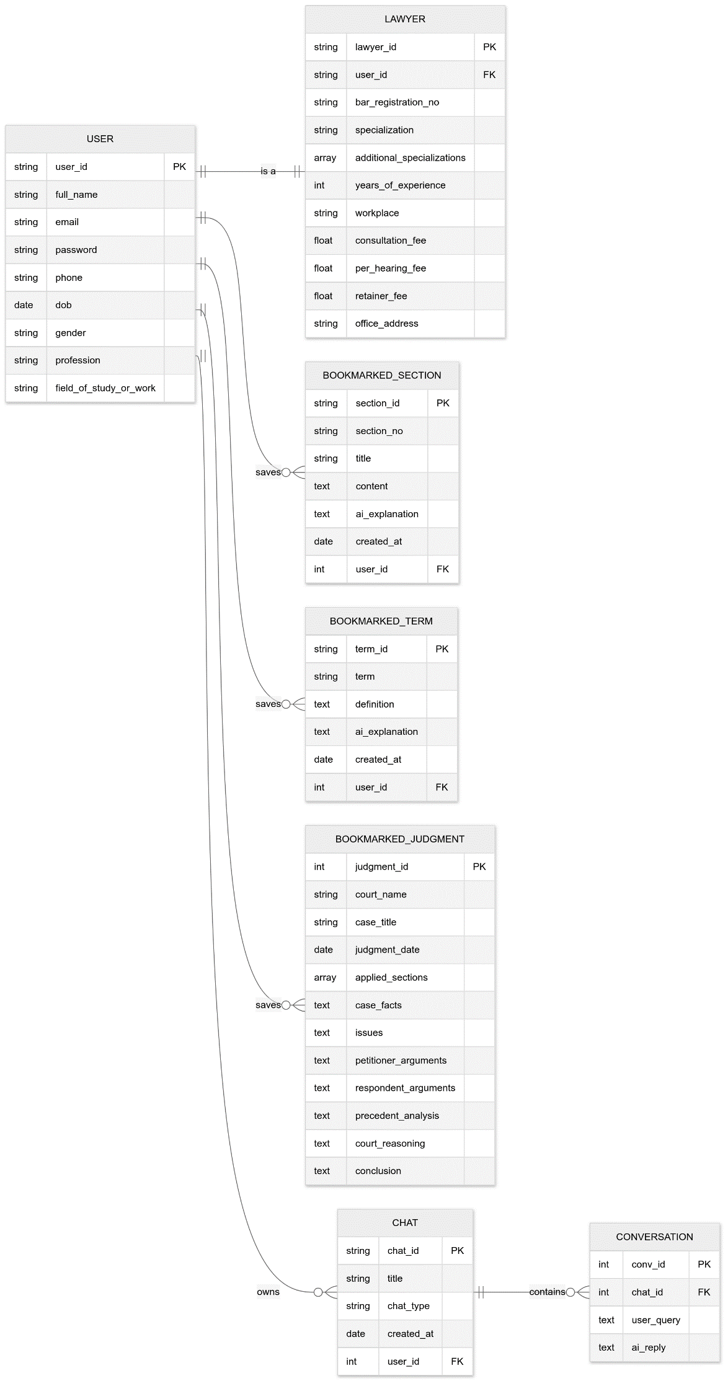4.1 Design Diag**rams**

**4.1.1 ER Diagram**

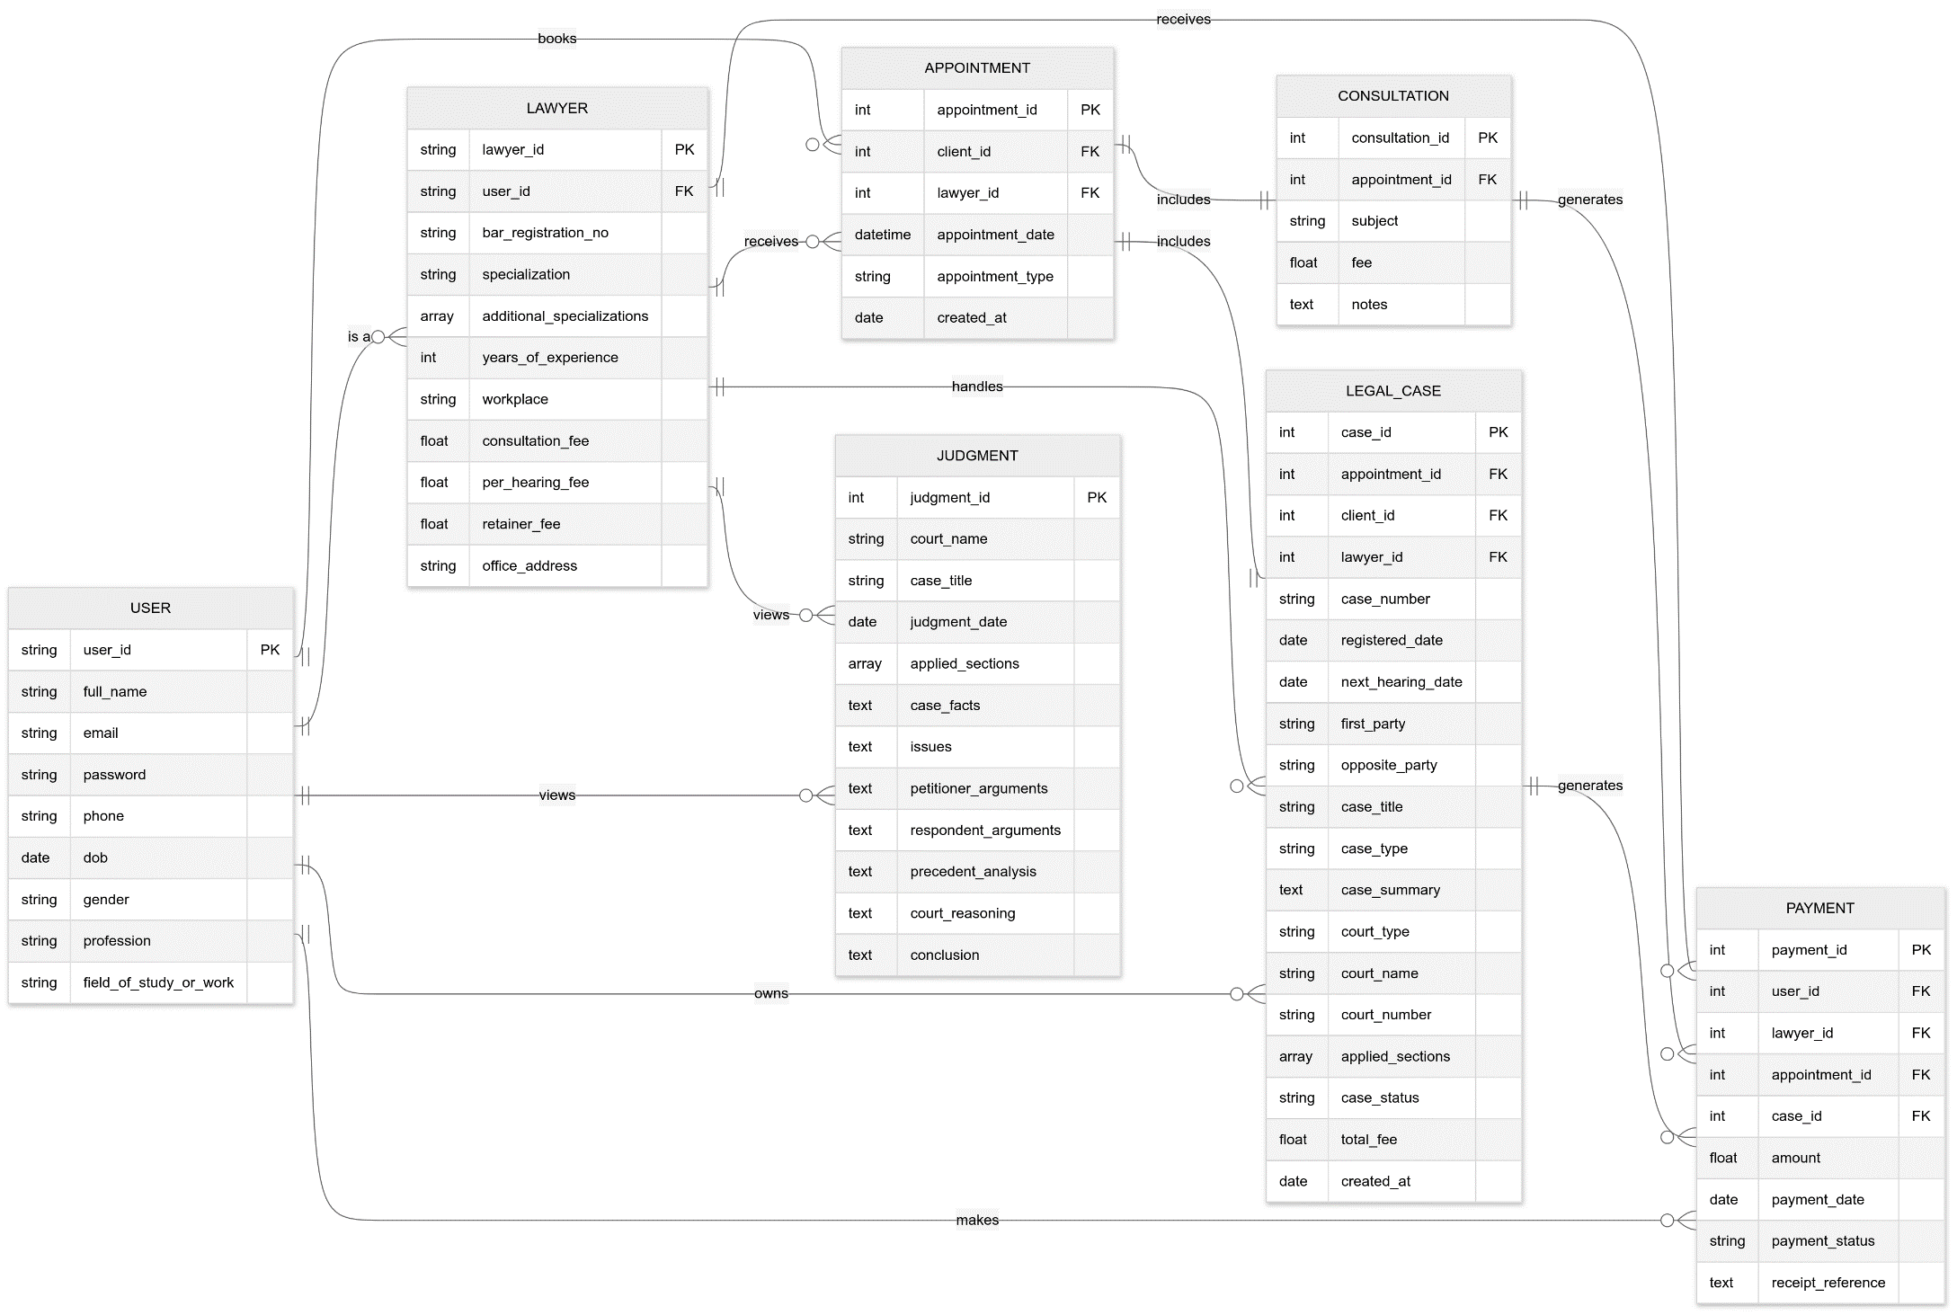



**4.1.2 Class Diagram**

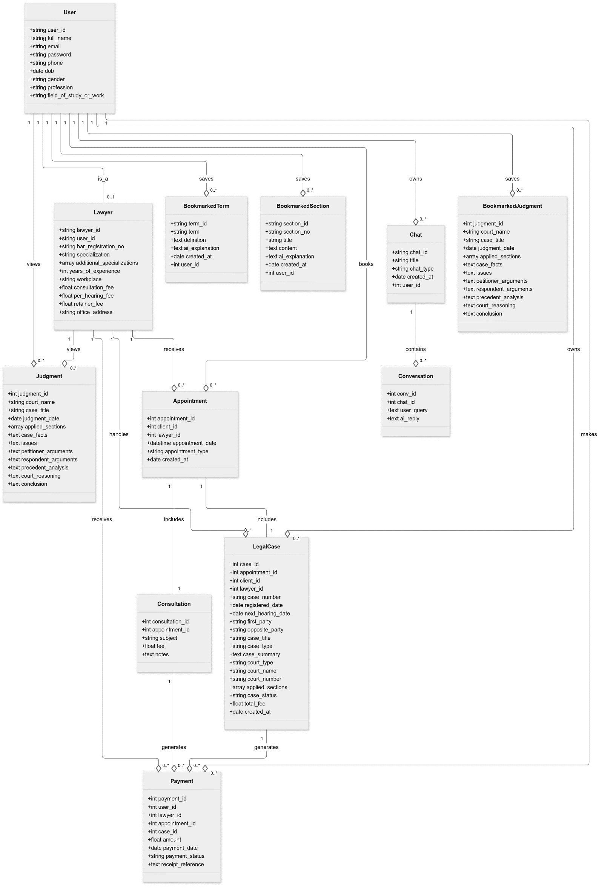

**4.1.3 Object Diagram**

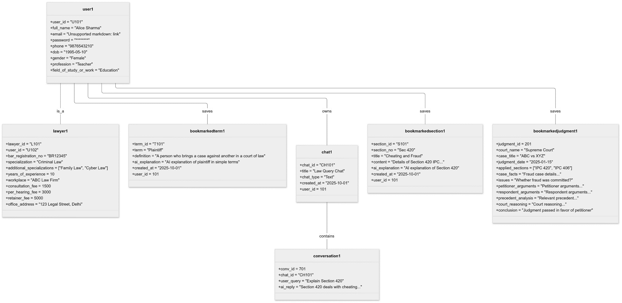

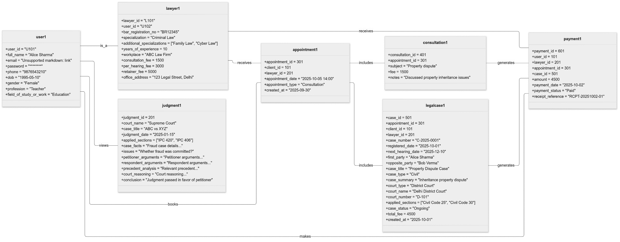

**4.1.4 Use Case Diagram**

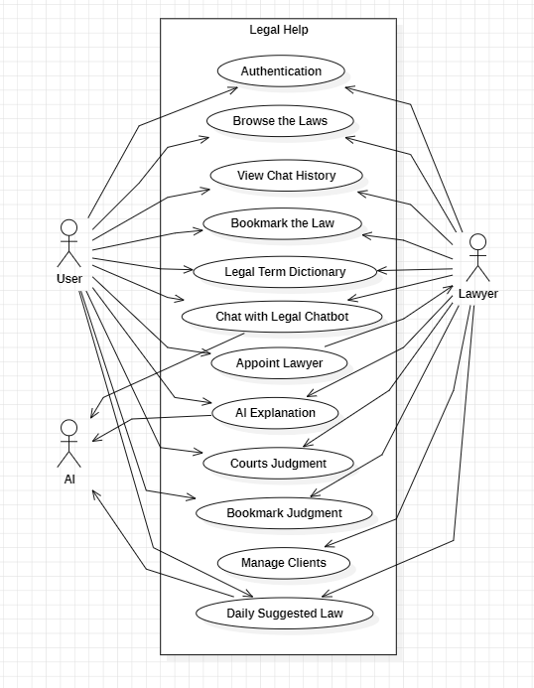

**4.1.5 Sequence Diagram**

1. Authentication:

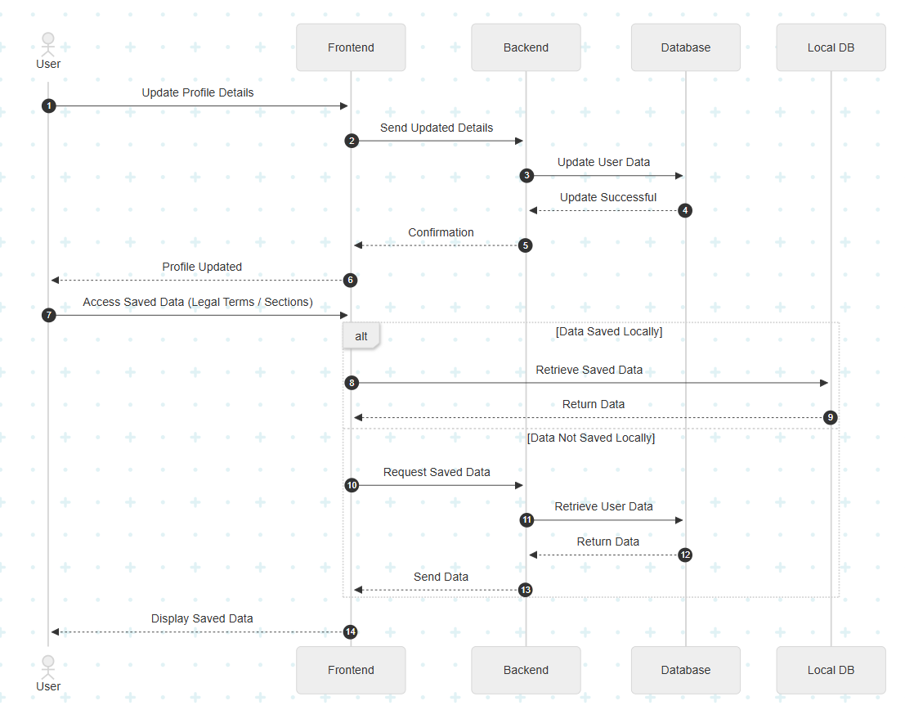

2. Profile and Saved Data:

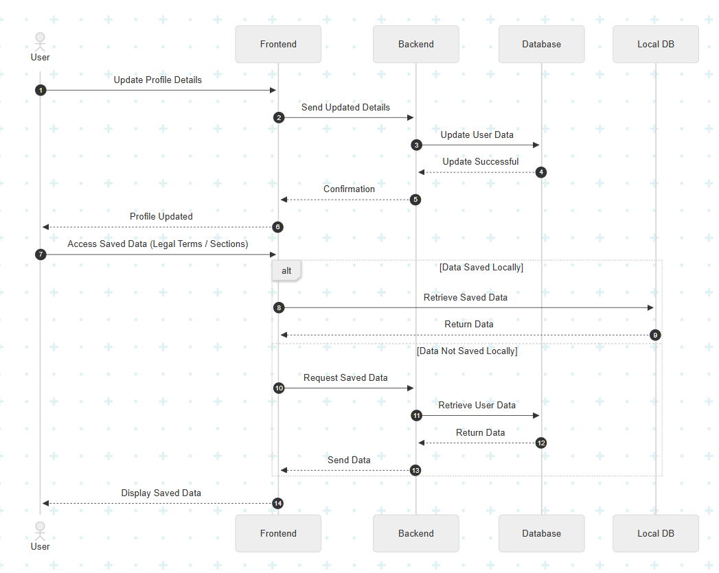

3. Browse Law:

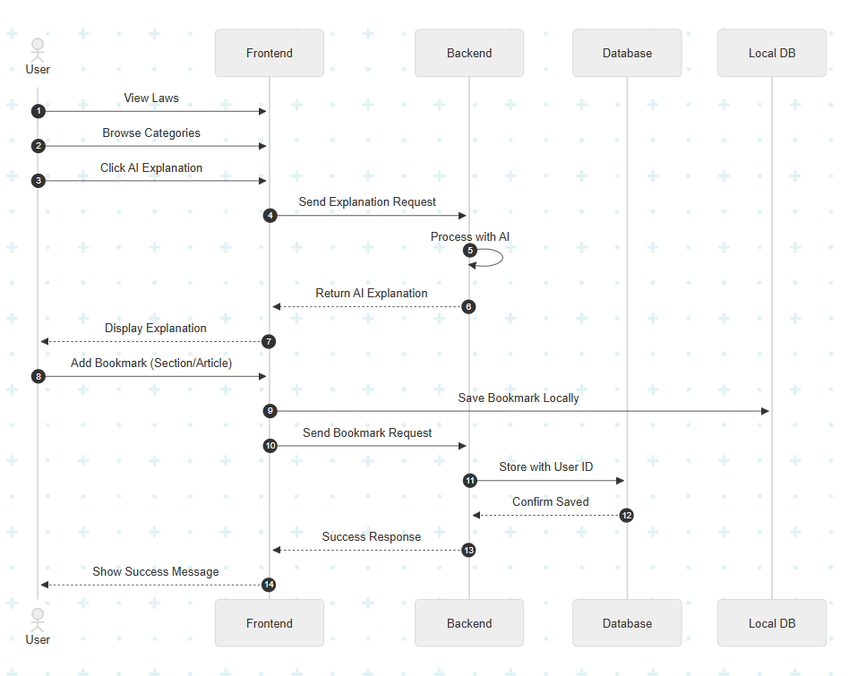

1. Personalize Daily Law:

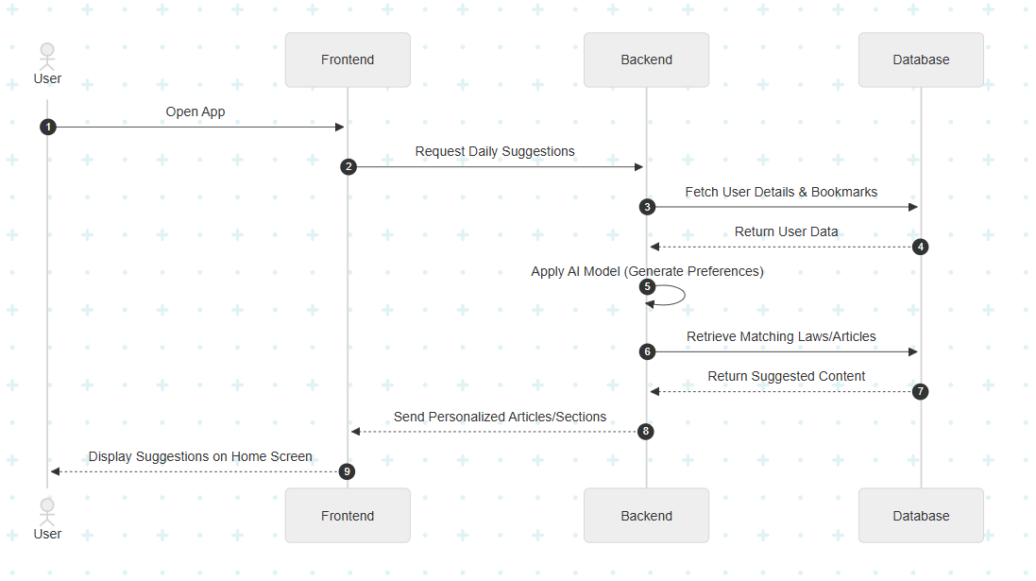

1. Legal Chatbot:

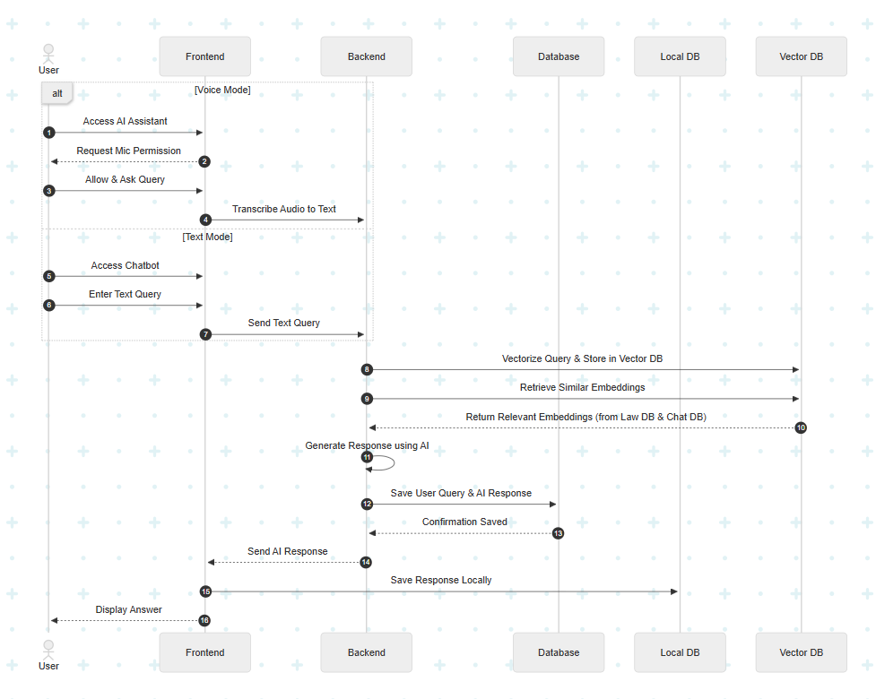

1. Judgements and Legal Terms:

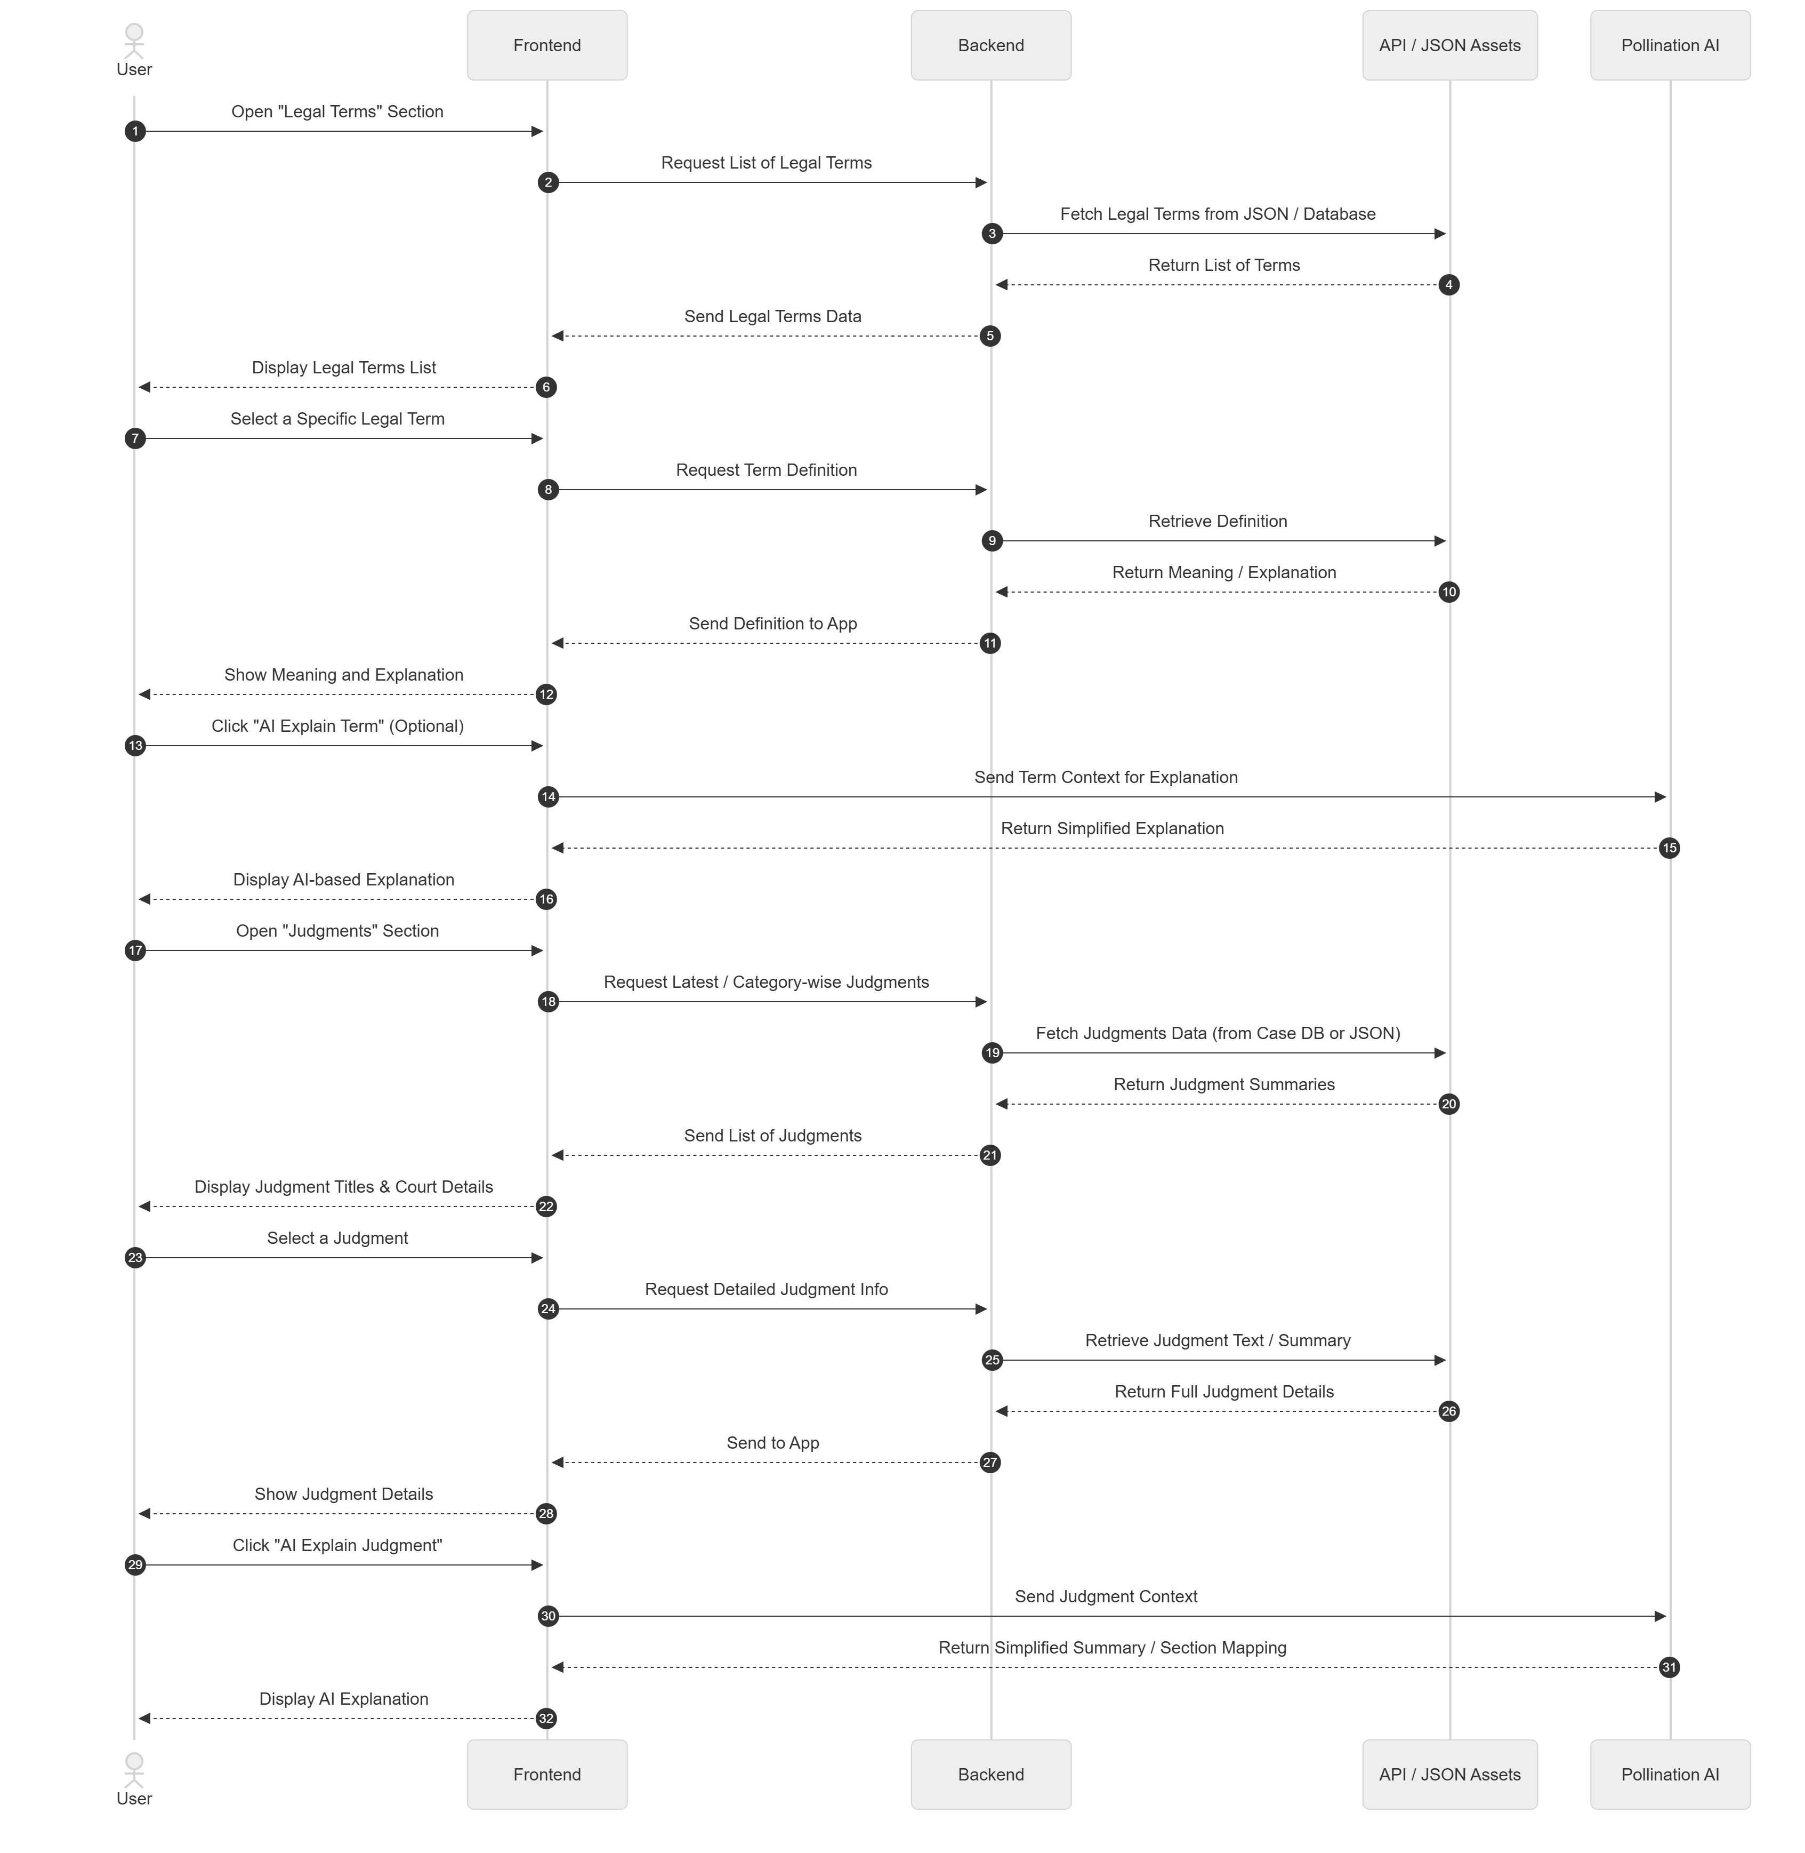

1. Lawyer Appointment:

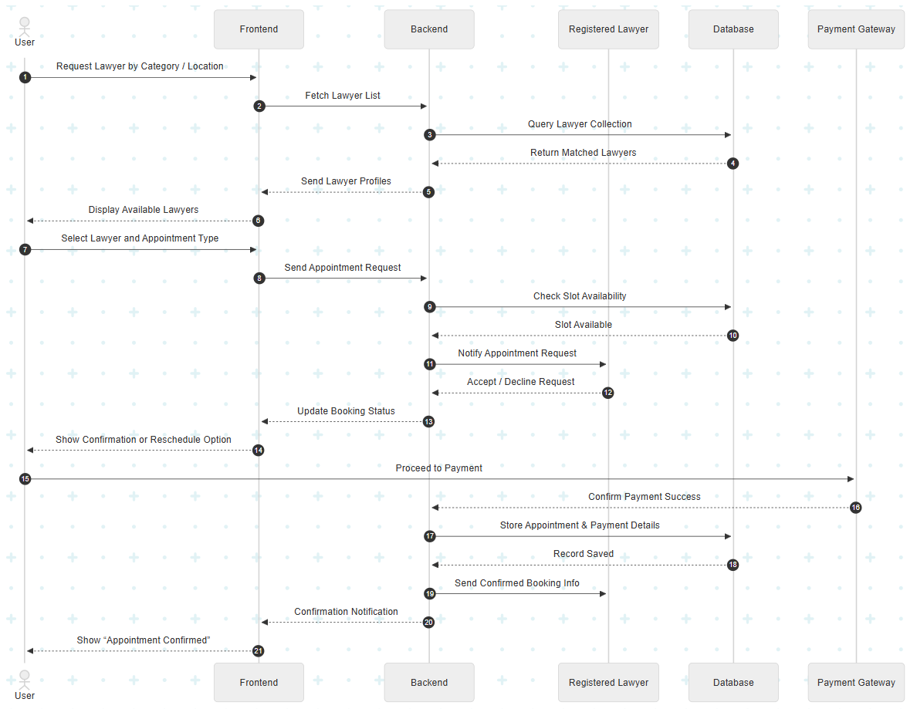

**4.1.6 Activity Diagram:**

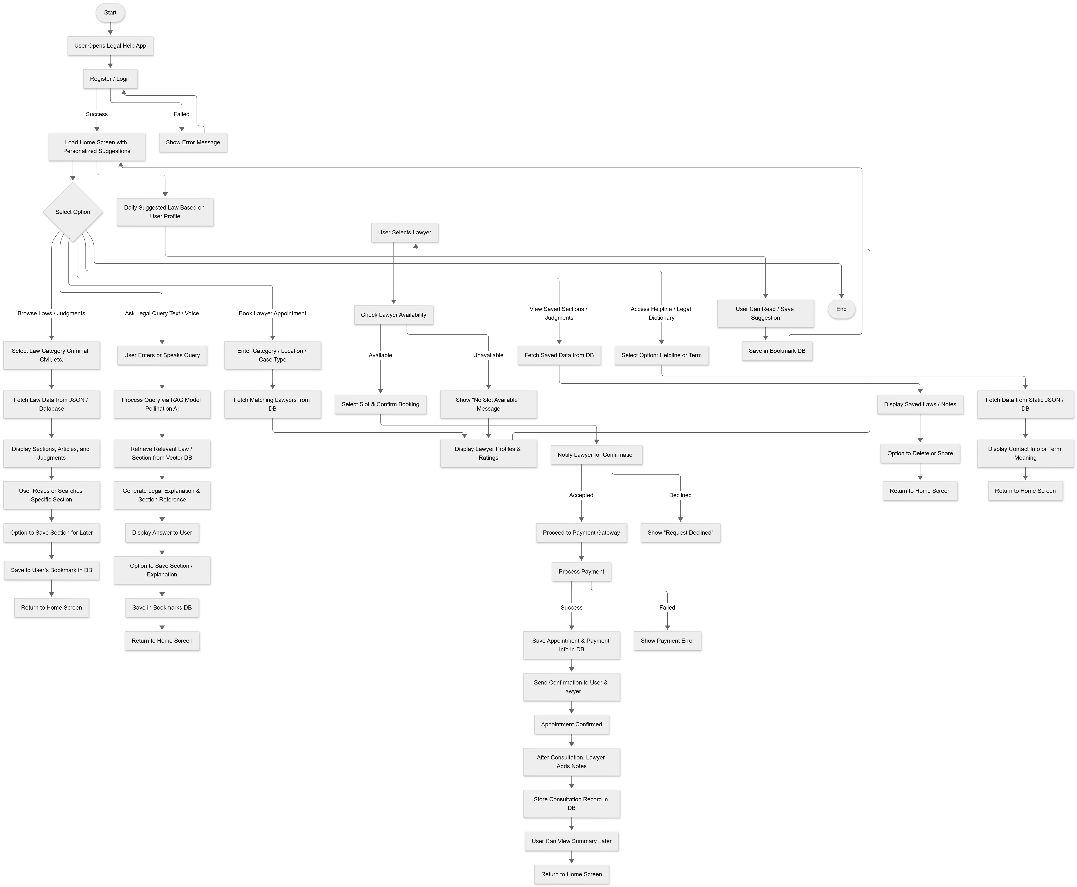

**4.1.7 Data Flow Diagram:**

**0th Level :**

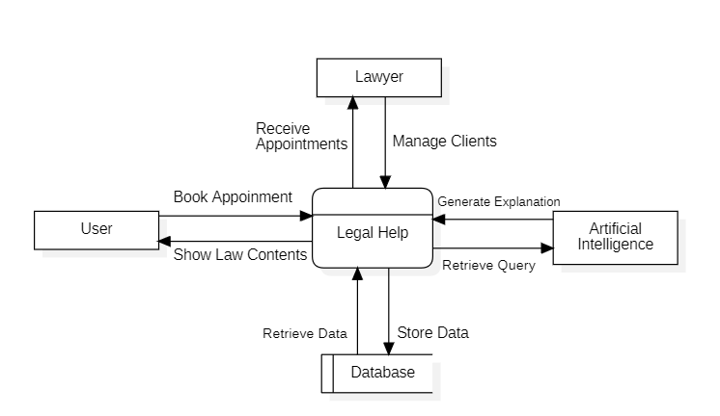

**1st Level :**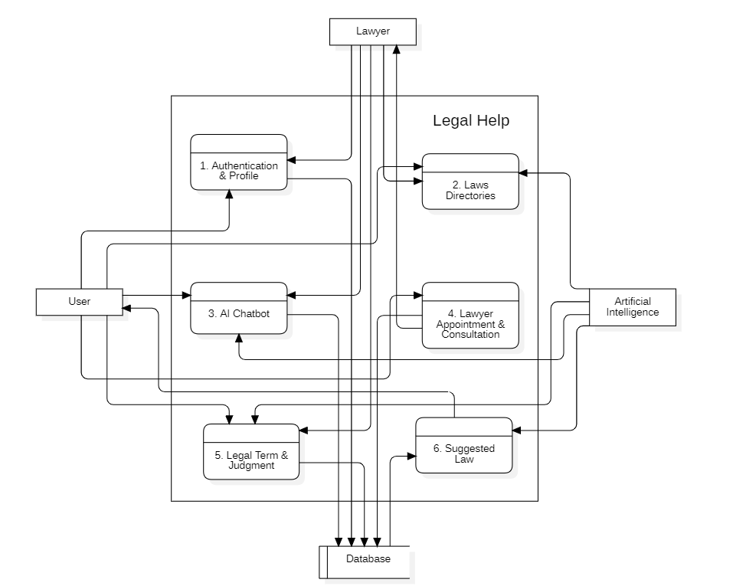

**2nd Level :**

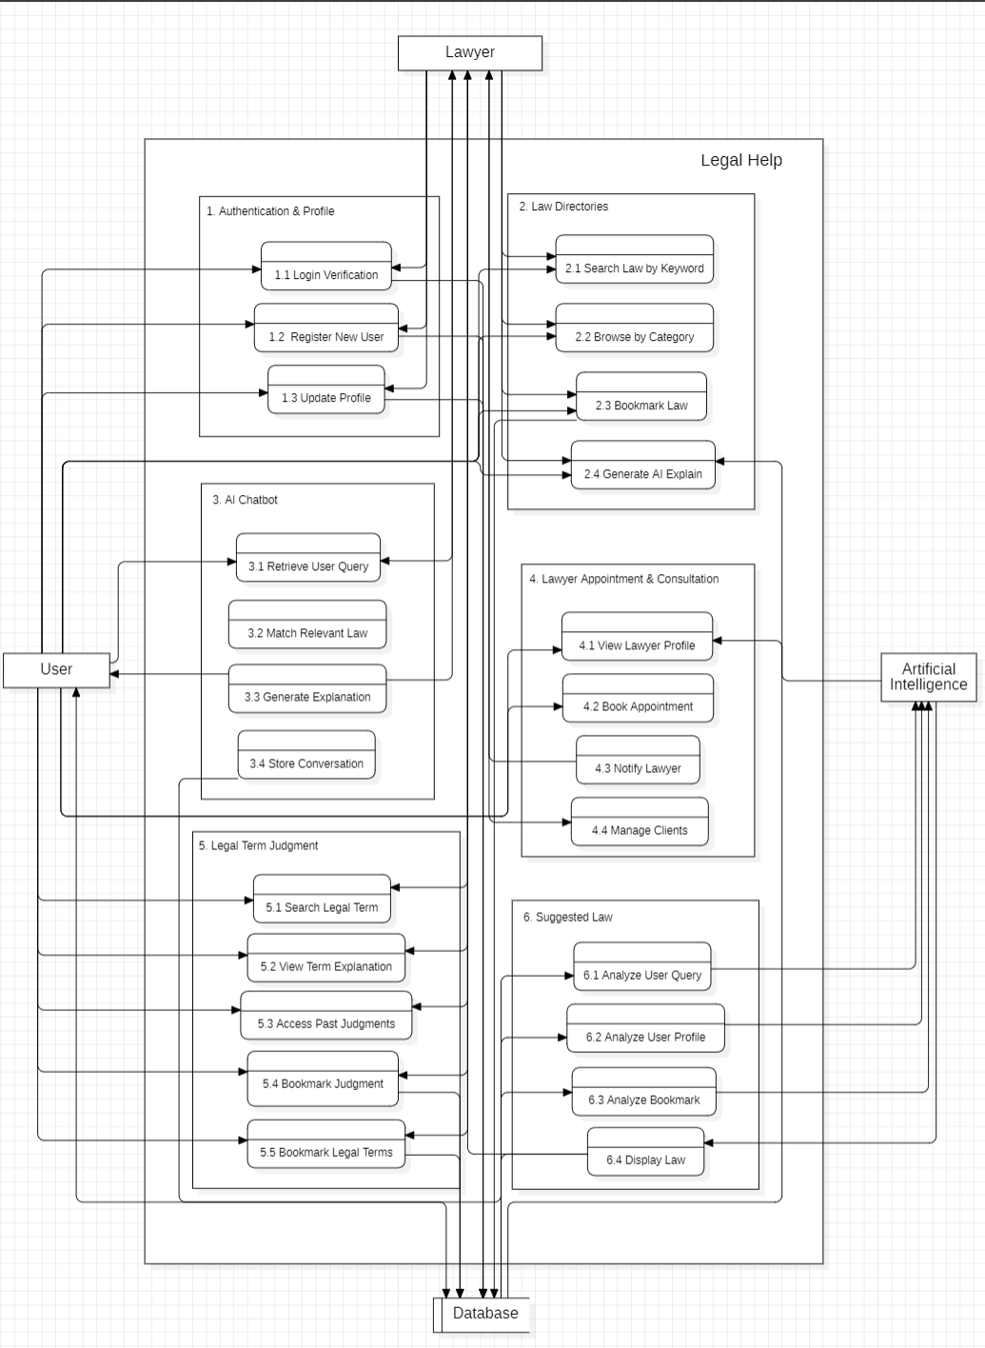

# 4.2 Module Design The Legal Help system is designed with a modular architecture to ensure scalability, maintainability, and efficient development. Each module performs a distinct function but interacts with other modules through secure APIs. This modular approach helps in easy debugging, future enhancements, and clear separation of frontend and backend responsibilities.

#### 4.2.1 Module Names with Description

### ****1. Authentication Module****

This module is responsible for managing **user and lawyer authentication** processes.  
It provides secure registration, login, and session management using encryption and token-based access.

**Functions:**

* Register new users (citizen or lawyer).
* Verify login credentials using MongoDB.
* Maintain active sessions with JWT tokens.
* Handle forgot-password and profile management.

**Interaction:**

* Frontend communicates via REST API with Node.js backend.
* Backend validates and retrieves data from the users and lawyers collections.

### ****2. Law Access Module****

This module allows users to **browse laws** categorized under the Indian Constitution, Criminal, Civil, and Other Laws.  
Laws are stored as structured JSON files within the Flutter app’s assets for offline access.

**Functions:**

* Display categorized list of laws and sections.
* Search by keywords or article numbers.
* Fetch AI-generated explanations for each section.
* Save and bookmark favorite laws.

**Interaction:**

* Fetch data from JSON or MongoDB.
* Integrate with the **Saved Section Module** for storing bookmarks.

****3. Chatbot Module****

The chatbot acts as a **virtual legal assistant** that answers user queries.  
It is implemented using a **RAG (Retrieval-Augmented Generation)** model integrated with **Pollination AI API** and **Qdrant Vector Database**.

**Functions:**

* Accept text or voice-based legal queries.
* Retrieve the most relevant law section using vector embeddings.
* Provide AI-generated explanations in simple terms.
* Suggest applicable sections for user’s situation.

**Interaction:**

* Uses Pollination API for AI response generation.
* Connects to Qdrant vector database to retrieve law embeddings.
* Integrates with the Law Access module for section references.

****4. Saved Section Module****

This module enables users to **bookmark** or **save specific articles/sections** for future reference.

**Functions:**

* Add or remove sections from saved list.
* Display all saved articles in a categorized manner.
* Sync saved data with cloud (MongoDB) for cross-device access.

**Interaction:**

* Connected with user profile and Law Access Module.
* Uses saved_sections collection for storage.

### ****5. Judgment Module****

This module helps users and lawyers to **view and study real court judgments** categorized by **court, year, or law type**.

**Functions:**

* Search and filter judgments based on law type or keywords.
* Display full judgment summary and applied sections.
* Enable AI-based explanation or case relevance check.
* Allow lawyers to upload or bookmark judgments for future use.

**Interaction:**

* Connects to the judgments collection in MongoDB.
* Uses AI model to extract applied sections from judgments.

### ****6. Lawyer Appointment Module****

This module enables users to **consult or hire lawyers** through the app.

**Functions:**

* Search lawyer by name, specialization, or location.
* View lawyer profile, experience, and consultation fee.
* Book appointment and make payment for consultation.
* Track case updates and communication between user and lawyer.

**Interaction:**

* Integrates with Authentication and Payment APIs.
* Stores data in appointments collection.
* Enables lawyer-side dashboard for case management.

****7. Legal Dictionary Module****

This module provides definitions and explanations of **legal terms and terminologies** to make users legally aware.

**Functions:**

* Display terms alphabetically or searchable.
* Provide short and AI-generated detailed explanations.
* Link legal terms with relevant laws or case examples.

**Interaction:**

* Fetches data from the dictionary collection.
* Connects with Chatbot and Law Access Module for contextual linking.

****8. Daily Suggested Law Module****

This module personalizes the app experience by recommending **daily law articles** to users.

**Functions:**

* Suggest daily law based on user’s age, profession, or interests.
* Display as a notification or card on the home screen.
* Store user interaction to improve future recommendations.

**Interaction:**

* Uses AI model to analyze user data.
* Fetches law content dynamically from the law dataset.

4.2.2 Module Functionality

****1. Authentication Functionality****

* User registers with necessary details; lawyers add additional info like bar registration number.
* Credentials are securely stored (hashed) in MongoDB.
* Login tokens ensure only authenticated users access premium features like Chatbot or Appointment.

****2. Law Access Functionality****

* Users can view categorized laws offline (via JSON) or online (via API).
* Dynamic AI explanation popup for every section/article.
* Users can save articles, share them, or open directly in chatbot for query discussion.

****3. Chatbot Functionality****

* Accepts text/voice query and processes it via NLP.
* Searches for relevant law in Qdrant vector store.
* Returns precise law name, section, and explanation.
* Provides simplified responses for general citizens, detailed ones for lawyers.

****4. Saved Section Functionality****

* Allows bookmarking of important sections.
* Saved data linked to user ID for personalized storage.
* Users can easily revisit saved sections through a separate screen.

****5. Judgment Functionality****

* Allows users to explore past judgments for reference.
* Displays summary, date, and related law sections.
* Offers filtering by law category or court.
* Helps lawyers prepare or reference cases efficiently.

****6. Lawyer Appointment Functionality****

* Enables one-on-one consultation scheduling.
* Payment gateway integration ensures secure payment.
* Lawyers can update case status and progress.
* Appointment notifications and reminders handled by backend cron jobs.

****7. Legal Dictionary Functionality****

* Provides a searchable index of legal terms.
* Each term links to relevant IPC/Constitution sections.
* AI explanation available for deeper understanding.

****8. Daily Suggested Law Functionality****

* Based on user profile data (profession, gender, interest).
* AI engine selects relevant sections/articles each day.
* Notification triggers display on home screen.

****Inter-Module Communication****

All modules interact via **REST APIs** using Node.js and Express, and share data through **MongoDB** collections. The **Flutter frontend** ensures smooth UI transitions, while **AI services** and **Qdrant** provide smart intelligence capabilities.

# 4.3 Schema **Design**

4.3.1 Database Design

The database design for the Legal Help application has been structured to efficiently store, retrieve, and manage data related to users, lawyers, laws, judgments, helpline numbers, and legal terms. The schema follows a relational model using MongoDB collections, while ensuring optimal access and retrieval performance.

****Entities and Key Attributes:****

* **User** – Stores information about general users and includes user_id (Primary Key), full_name, email, password, phone, dob, gender, profession, and field_of_study_or_work.
* **Lawyer** – Contains lawyer-specific details with lawyer_id (Primary Key), user_id (Foreign Key), bar_registration_no, specialization, experience, and availability.
* **Law** – Stores categorized legal content including law_id (Primary Key), category, title, section_number, and content.
* **Judgment** – Maintains records of court judgments with judgment_id (Primary Key), case_title, court_name, date, related_laws, and summary.
* **Legal Term** – Contains definitions and explanations with term_id (Primary Key), term_name, and description.

Relationships are established between users and lawyers, users and saved laws, and laws with judgments to maintain referential integrity. Collections are indexed for frequent queries, such as law section searches, judgment retrieval, and chatbot responses.

# 4.4 Data Integrity and Constraints

4.4.1 Data Integrity.

Ensuring data integrity is critical to maintain the accuracy, consistency, and reliability of the Legal Help system. The following integrity measures are implemented:

* **Consistency:** Updates to user or lawyer information reflect across related collections to avoid discrepancies.
* **Accuracy:** Mandatory validation on inputs such as email format, phone number, and date of birth ensures data correctness.
* **Timeliness:** System automatically records timestamps for user registrations, law additions, and judgment updates.
* **Completeness:** All required fields in entities must be filled before submission to prevent missing critical information.

#### 4.**4.2 Data Constraints**

To enforce data integrity at the database level, the following constraints are applied:

* **Primary Key Constraints:** Each collection has a unique identifier (user_id, lawyer_id, law_id, judgment_id) to uniquely identify records.
* **Foreign Key Constraints:** Relationships such as user_id in Lawyer collection ensure referential linkage between users and lawyer profiles.
* **Not Null Constraints:** Essential fields like full_name, email, password, section_number, and content are mandatory.
* **Value Constraints:** Fields like gender accept only predefined values (e.g., Male, Female, Other), and phone must be a valid 10-digit number.
* **Unique Constraints:** Email addresses and bar registration numbers are unique to prevent duplicate records.

These constraints collectively ensure high-quality, reliable, and secure data management across the system.

# 4.5 User Interface Design

The **User Interface (UI)** of the *Legal Help* application is designed to be **simple, intuitive, and user-friendly**, ensuring that even non-technical users can easily browse laws, ask questions, and access legal resources. The design follows modern **UI/UX principles** with a focus on accessibility, responsiveness, and clarity.

# 4.5.1 Design Considerations

**Color Scheme**

* A clean, minimal white and blue color scheme is used, signifying trust and professionalism which is crucial for legal-tech apps.​
* Blue is consistently applied for CTAs (Call-to-Action) such as buttons and section highlights, improving focus without overwhelming the user.​
* The light theme option with soft color contrasts makes the UI visually comfortable and accessible.​

**Typography**

* Simple, readable sans-serif fonts are used to enhance readability and keep the content accessible on all devices.​
* Font size hierarchy (large for headings, medium for section titles, normal for body text) provides clear visual separation and improves scan-ability.​

**Icons & Graphics**

* The UI incorporates minimal vector icons and profile illustrations, which enriches navigation and adds a friendly character without cluttering the layout.​
* Illustrative graphics (such as appointment confirmations) are used purposefully to aid communication and create an engaging experience.​

**Layout and Navigation**

* Information is grouped into cards and clearly divided sections for easy browsing (e.g., chapter tabs, lawyer list, appointment details).​
* Persistent bottom navigation bar helps users switch between Home, Chatbook, Lawyers, Judgments, and Profile quickly, supporting intuitive app flow.​
* Sideways scrollable sections and horizontal lists enable effective exploration of lengthy content like legal chapters or client/lawyer lists.​

**Responsiveness**

* The design demonstrates responsiveness by displaying lists, cards, and controls that resize or reflow neatly to fit different screen sizes.​
* Interactive elements such as toggles, filter dropdowns, and buttons are sized for comfortable tapping on touch devices.

**Accessibility**

* Good color contrast in text and buttons improves accessibility for all users, including those with vision challenges.
* Icons and button labels provide context richness, aiding users who rely on assistive tools.​
* The presence of a language toggle indicates attention to inclusivity for non-English users.​

**Consistency & Branding**

* Uniform style for forms, buttons, and cards delivers a consistent visual brand for the application.​
* Design patterns are repeated across screens, reducing user learning curve and enhancing overall usability.

**4.5.2 UI/UX Design**

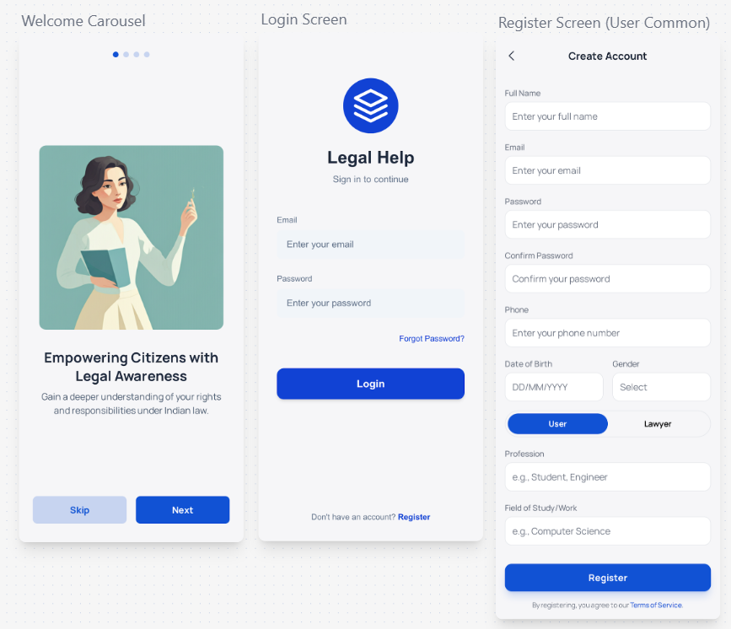

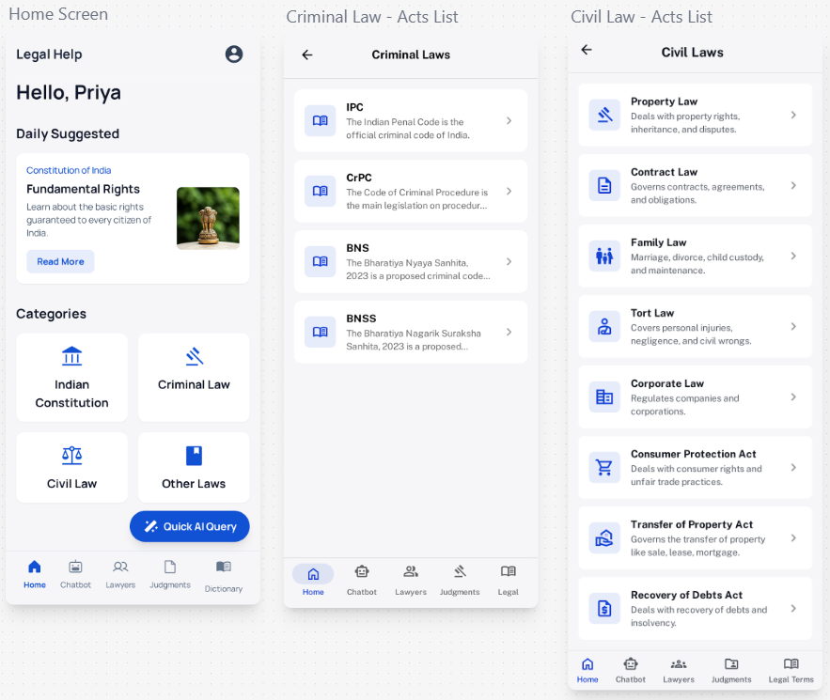

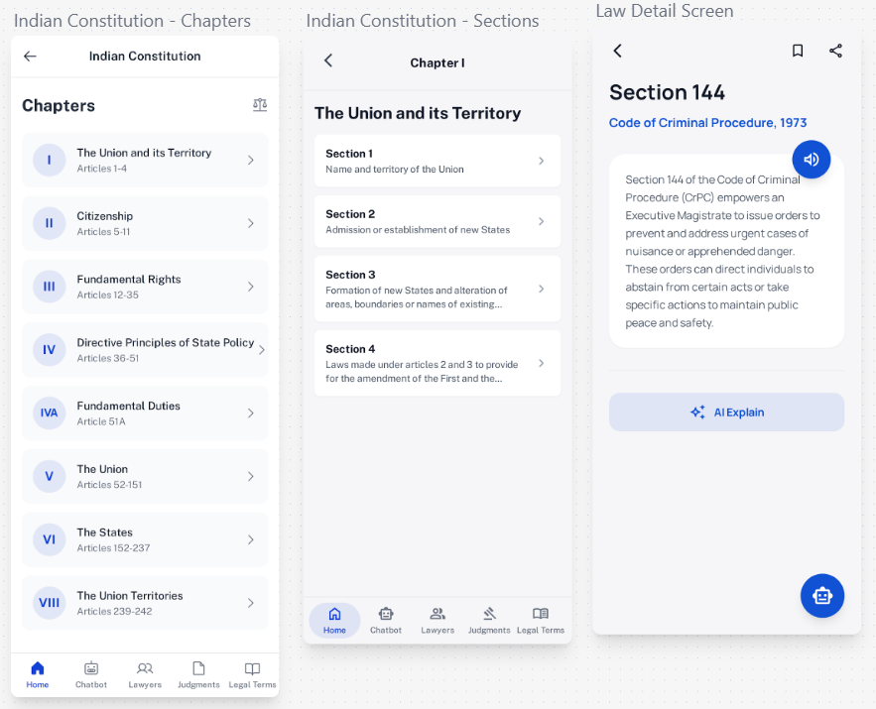

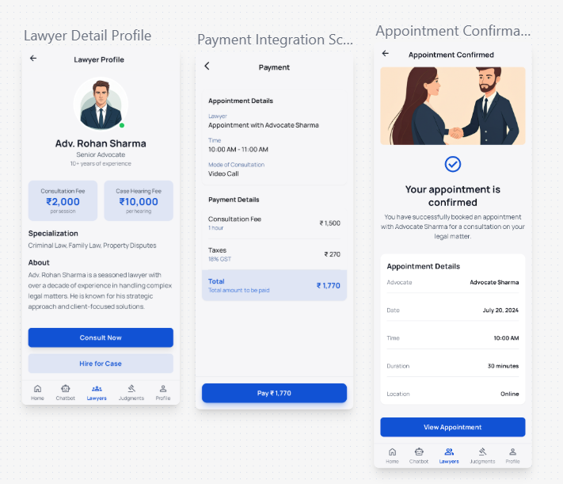

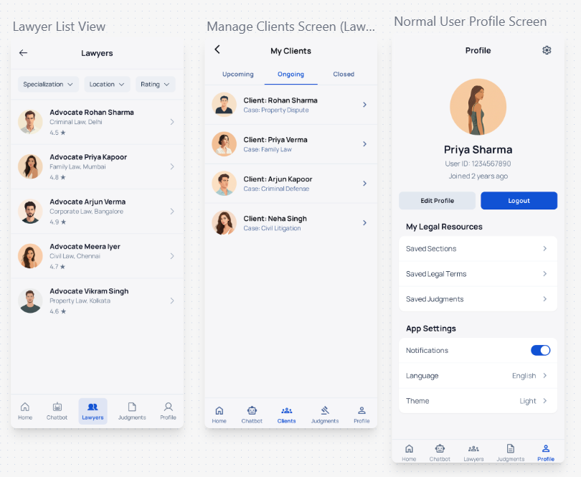

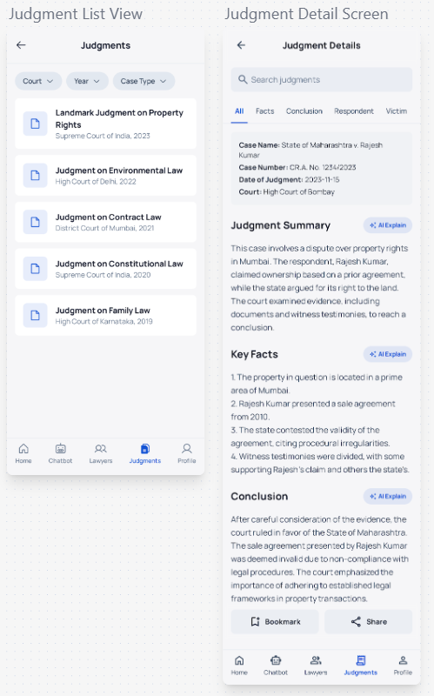

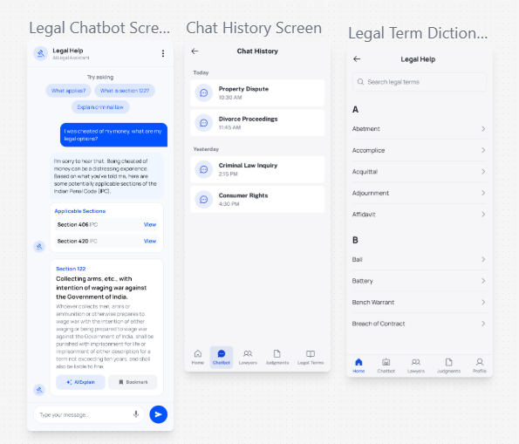

# 4.6 Security Issues

Security is a crucial aspect of the Legal Help application, as it deals with sensitive information such as user profiles, queries, and legal references. Ensuring confidentiality, integrity, and availability (CIA) of data is necessary to maintain user trust and the reliability of the system.

4.6.1 Security Issues Related to Project

1. **Data Privacy**
   * Users may enter personal or sensitive queries in the chatbot. If not handled securely, this data could be exposed.
2. **Unauthorized Access**
   * Without proper authentication, attackers could access or manipulate user bookmarks, profiles, or helpline information.
3. **Data Integrity Threats**
   * Incorrect or tampered legal data could mislead users. Integrity must be protected against unauthorized modifications.
4. **API Security**
   * Integration with AI APIs, Speech-to-Text services, and cloud databases introduces the risk of API misuse or interception.
5. **Network Vulnerabilities**
   * Since the app communicates with cloud services, insecure transmission (if not encrypted) could lead to **man-in-the-middle (MITM) attacks**.
6. **Malicious Use of AI**
   * Users may attempt to misuse the chatbot for irrelevant or harmful queries, leading to unreliable or unintended outputs.

4.6.2 Security Policy and Plan

To address the above risks, the following security policies and practices are implemented:

1. **Authentication & Authorization**
   * Firebase Authentication (Email/Password, Google login) ensures that only verified users can access personalized features.
   * Role-based access controls prevent unauthorized actions.
2. **Data Encryption**
   * All data transmitted between the app and backend uses **HTTPS (SSL/TLS encryption)**.
   * Sensitive user data stored in Firebase is encrypted at rest.
3. **Data Integrity Controls**
   * Legal texts are stored in **read-only JSON assets** to prevent unauthorized tampering.
   * Backend checks ensure AI explanations always cite retrieved law sections.
4. **API Security**
   * Secure API keys are used for accessing AI and STT services.
   * Rate limiting is implemented to prevent abuse of external APIs.
5. **Regular Updates & Monitoring**
   * Libraries and dependencies (Flutter, Firebase, AI SDKs) are updated regularly to patch vulnerabilities.
   * User activity logs are monitored for suspicious behavior.
6. **User Privacy Policy**
   * The app provides a clear **privacy statement** explaining how user data is collected, stored, and used.
   * Personal queries are not shared with third parties without user consent.
7. **Misuse Prevention**
   * Filters are applied to restrict irrelevant or abusive queries to the AI chatbot.
   * Users can report incorrect or misleading explanations for review.

# 4.6 Cost Estimation

**Cost estimation** is the process of evaluating the overall financial requirements for developing and implementing the Legal Help application. It helps to determine the project’s feasibility and resource utilization in terms of time, manpower, and technology. The total cost of the project can be broadly divided into hardware, software, and manpower (development) costs.  
In addition, cost estimation provides a clear understanding of the budget allocation for each phase of development, ensuring effective planning and control over project expenses. It also helps in identifying areas where cost optimization can be achieved without compromising the quality or functionality of the system.

****1. Hardware Cost****

| **Sr. No.** | **Component** | **Quantity** | **Approx. Cost (₹)** | **Total (₹)** |
| --- | --- | --- | --- | --- |
| 1 | Laptop/Desktop (for  development and testing) | 1 | 45,000 | 45,000 |
| 2 | Internet Connection | 1 | 1,000/month × 6 months | 6,000 |
| 3 | Storage/Backup Devices | 1 | 2,000 | 2,000 |
| **Total Hardware Cost** |  |  |  | **₹53,000** |

****2. Software Cost****

Most of the software and tools used for the Legal Help system are open-source or freely available, minimizing expenses.

| **Sr. No.** | **Software** | **Type** | **Cost (₹)** |
| --- | --- | --- | --- |
| 1 | Flutter SDK | Open Source | 0 |
| 2 | Node.js and Express | Open Source | 0 |
| 3 | MongoDB Atlas | Free Tier | 0 |
| 4 | Pollination AI API | Free Tier (limited) | 0 |
| 5 | Android Studio / VS Code | Free | 0 |
| **Total Software Cost** |  |  | **₹0** |

****3. Manpower / Development Cost****

This is the main cost of the project, which includes the efforts of developers, testers, and deployment team members.  
The following assumptions are considered:

* **Working Hours per Month:** 180 hours
* **Working Hours per Day:** 6 hours
* **Rate per Hour:** ₹500
* **Project Duration:** 6 months

**Calculation:**

Monthly Manpower Cost=180 hrs×₹500=₹90,000

Total Manpower Cost (6 months) = ₹90,000×6 = ₹5,40,000

| **Role** | **Duration (Months)** | **Cost (₹)** |
| --- | --- | --- |
| Programmer / Developer | 6 | 3,00,000 |
| Tester | 3 | 1,20,000 |
| Deployment & Maintenance | 3 | 1,20,000 |
| **Total Manpower Cost** |  | **₹5,40,000** |

****4. Miscellaneous Cost****

| **Sr. No.** | **Item** | **Description** | **Cost (₹)** |
| --- | --- | --- | --- |
| 1 | Hosting / Domain | Temporary hosting for demo | 3,000 |
| 2 | Documentation & Printing | Project report, binding, etc. | 1,500 |
| 3 | Miscellaneous Expenses | Testing and API trials | 2,000 |
| **Total Miscellaneous Cost** |  |  | **₹6,500** |

****5. Total Estimated Cost****

| **Category** | **Cost (₹)** |
| --- | --- |
| Hardware Cost | 53,000 |
| Software Cost | 0 |
| Manpower / Development Cost | 5,40,000 |
| Miscellaneous Cost | 6,500 |
| **Grand Total** | **₹5,99,500 (Approx. ₹6 Lakh)** |

****6. Conclusion****

The total estimated cost for developing the Legal Help system is approximately **₹6,00,000**. The major portion of the budget is attributed to **manpower and development**, which includes programming, testing, and deployment activities.  
Since most of the software resources are open-source and free, the project remains cost-efficient and feasible for prototype or academic-level implementation.